A World Awaits You: People with Non-Apparent Disabilities Abroad
  - A Publication of the National Clearinghouse on Disability and Exchange

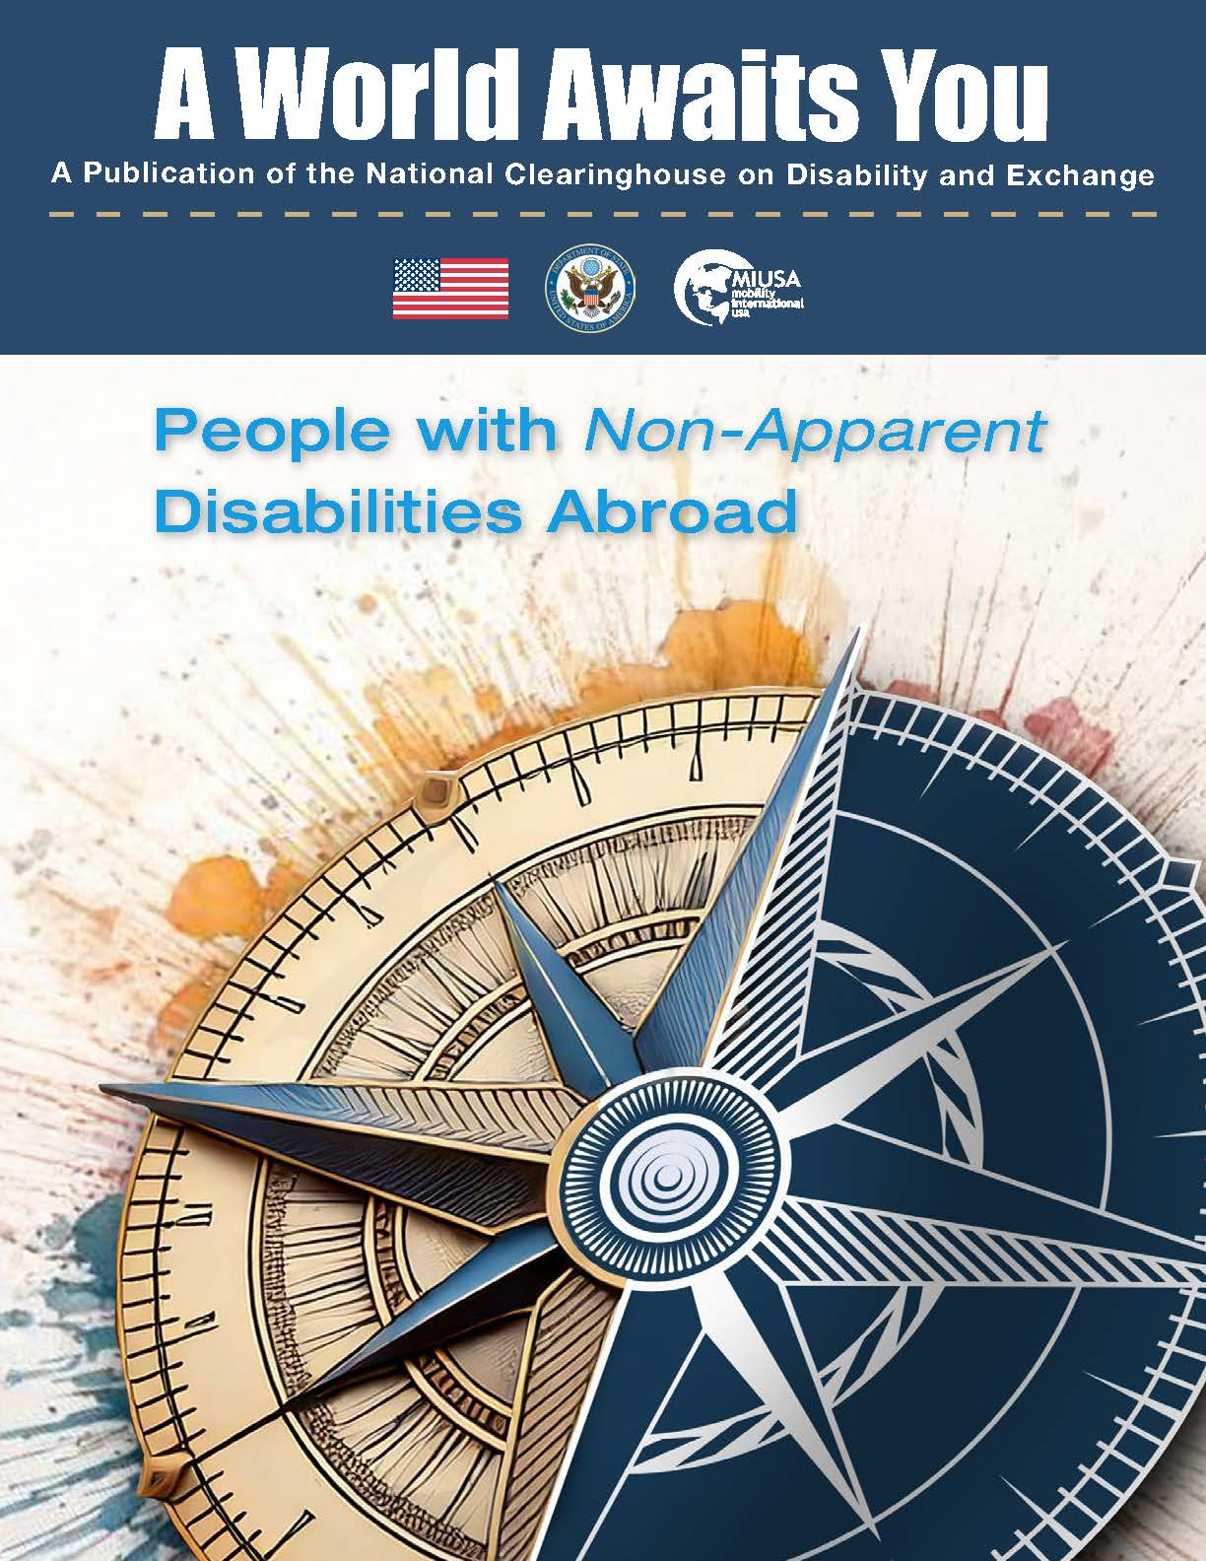

Table of Contents
Publication Information 5
Introduction to People with Non-Apparent Disabilities Abroad 6
A Note About Language 6
Lindsey Pamlanye: From the U.S. to Ireland with Hydrocephalus 7
My Chronic Health Condition 7
From Non-starters to Starting Points 7
The Unthinkable Becomes Thinkable 8
Lindsey’s Photos 9
How a Sunflower Promotes Accessible Air Travel 13
Bethany Kuwitzky: Navigating Disability Disclosure During Study Abroad in Iceland (When Not Disclosing Works) 15
Disability Was Not at the Forefront 15
Non-Disclosure Does Not Mean No Disclosure 16
A Formative Experience 16
Bethany’s Photos 17
Ways Exchange Professionals Can Encourage Participants to Disclose their Disabilities: From Bethany’s Perspective 22
One-on-One Situations 22
In Larger Group Settings 22
Ally Baharoon: Living, Speaking, and Dreaming on the Mandela Washington Fellowship 24
Finding a Vocation Through Disability 24
Observing a Different Way 25
A Renewed Commitment 25
About the Mandela-Washington Fellowship 26
Ally’s Photos 26
Kristen Popham: Taking Up Space in France 28
Proudly Fighting to be Believed 28
How to Cover a Chronic Health Condition in France 28
Accessing Exclusive Spaces through Disability 29
ETA is All About the Students 29
Kristen’s Photos 30
Nicole Bettè: Design Thinking in Stockholm, Sweden 33
A Mix of Disabilities 33
Rationing ADHD Medication 33
At Home Away from Home 34
Nicole’s Photo 35
About the Gilman Program 35
Ken Yamamoto: Understanding The World from Multiple Angles 36
Honn and Tatemae 36
A Target on Your Back 36
A New Perspective 37
Ken’s Tips for Preparing for Travel 37
Ken’s Photos 38
Qazi Fazli Azeem: What Will People Say About You? 40
A Life without a Diagnosis 40
Becoming an Advocate 41
Taking Risks and Making Discoveries 41
What Will People Say? 42
Fazli’s Photos 43

Publication Information
A World Awaits You (AWAY) is a publication of the National Clearinghouse on Disability and Exchange.

The National Clearinghouse on Disability and Exchange is a project of the U.S. Department of State's Bureau of Educational and Cultural Affairs, designed to increase the participation of people with disabilities in international exchange between the United States and other countries. It is supported in its implementation by Mobility International USA.

Editor: Justin Harford

Mobility International USA
132 E. Broadway, Suite 343
Eugene, Oregon USA 97401
Tel: +1 (541) 343-1284
Email: clearinghouse@miusa.org
Website: www.miusa.org/ncde

The information in this publication is provided for general informational purposes only. References do not constitute endorsement of any websites or other sources.

Copyright © 2024 Mobility International USA. All rights reserved. This publication may be printed for educational purposes only.

Introduction to People with Non-Apparent Disabilities Abroad
  - Edited by Justin Harford
When many people think about disability, they imagine somebody using a wheelchair or a cane; however, disability is not always visible. In fact, people with invisible disabilities, hidden disabilities, or non-apparent disabilities, actually represent a larger percentage of the population of students with disabilities both enrolled in higher education institutions and participating in study or volunteer abroad programs. Sometimes a non-apparent disability is eclipsed by other identities, and other times, it may cause a great deal of adversity, including when finding a place within the disability community. Unlike people with physical or sensory disabilities, however, participants with non-apparent disabilities sometimes have an option not to disclose– even to their friends and teachers with whom they interact every day. This can lead to a wider variety of approaches towards disclosure.
In this release of the AWAY Journal, we dig more deeply into the many facets of non-apparent disabilities as we explore the varied stories of people with non-apparent disabilities studying and volunteering abroad.
We hope that the experiences of these students will give you more insight into the management of chronic health conditions, mental health and learning disabilities, as well as the varied ways of approaching disclosure. ■

A Note About Language
We recognize that there are different ways of referring to people with non-apparent disabilities:
- "Invisible disabilities" is used by the Invisible Disabilities Association.
- "Hidden disabilities" is used by the organization that promotes the Sunflower lanyard, which individuals can use to convey their need for certain accommodations during air travel (learn more about the Hidden Disabilities Sunflower Program later in this issue).
- "Non-apparent disabilities" is the phrase we will use throughout this publication because it appears to be the word that is commonly used by U.S. organizations like World Institute on Disability and Disability:In as of the publication date.

Lindsey Pamlanye: From the U.S. to Ireland with Hydrocephalus

My first experience with international exchange was as a child when my family in the United States hosted students from Belfast, Northern Ireland through the Project Children program. Staying in touch with one of our visitors throughout the years had always left the lingering desire to explore my Irish roots and travel in the opposite direction, but the trip was never a forgone conclusion.

My Chronic Health Condition
I was born with Hydrocephalus which is a neurological condition that causes an abnormal fluid build up in the brain that can be fatal if untreated. The Hydrocephalus experience varies greatly from person to person but the most common treatment is a surgically implanted device called a shunt. There is no known cure. At the time I began pursuing international education after college, I had 6 total brain surgeries, all during childhood, all emergencies.

The idea of leaving my support system elicited many doubts. Could I get my medications? How could I afford it? Who would help me if I got sick? Over time I would come to see these questions as starting points rather than disqualifications.

A series of small steps made an impossible international move suddenly seem manageable. I started as a resident student during my undergraduate studies. In time I took trains and planes independently, went to doctors’ appointments alone, and did a post graduate service program out of state. These deceivingly minor accomplishments built on one another and, eventually, a chance conversation with someone visiting New York from Ireland was the push I needed to start researching programs, and it wasn’t long before I found a match. The Equality Studies Programme at University College Dublin (UCD) was a unique combination of everything I enjoyed, wanted to learn about, and hoped to pursue as a career. I was immediately sold and on the path to Dublin.

From Non-starters to Starting Points
A key part of my research was taking the time to reflect on my personal parameters for going abroad. I needed certain medical facilities. I only spoke English and I didn’t feel comfortable translating my needs, especially in an emergency. I had a deadline to finish my degree to keep my teaching license, and I also wanted to complete school before aging out of my parents’ health insurance plan. Managing my disability while abroad became a degree program on top of my masters. As a disabled non-EU student, I found applications, immigration, student loans, and travel processes fraught with institutionalized barriers. I had to source new doctors, navigate the immigration system, and do all of this on top of finishing grad school and also trying to immerse myself in a new culture. Honestly at times it felt impossible – and realistically, it was. Spoon Theory really helped me to understand why (read more about Spoon Theory after this story). I only had so much of myself to give on any day. I was familiar with the saying “you can’t pour from an empty bucket” and it’s incredibly accurate.

However, I was well connected with predeparture support like my local UCD Global Centre in New York and eventually the UCD Access and Lifelong Learning Office, as well as resources from the NCDE that were incredibly useful at all stages of my exchange. I consulted directly with my medical team but had also contacted Spina Bifida Hydrocephalus Ireland to better understand the local culture as it relates not only to my condition but disability as a whole. Lastly, I was supported by my connection to the international Lasallian education network, a global collection of educational centers advancing the mission of St. John Baptist De La Salle to bring a quality education to those at risk of exclusion. Lasallians welcomed me to Ireland and continued to step in as a local “family” at all stages of my time abroad.

My key reasonable accommodations included receiving lecture slides in advance, recording my classes, and flexible deadlines. Part of my disability involves chronic pain and trouble sleeping, which can make following extended lectures difficult. Being able to review the content and really take my time with comprehension made a huge difference.

The Unthinkable Becomes Thinkable

After completing my graduate school program, I continued living and working in Ireland on the 1G stayback visa which coincided with the COVID lockdowns. My worst case scenario - "what if I need brain surgery while abroad” - became significantly amplified. Now, it was “what if I need brain surgery during a global pandemic, in a lockdown, under significant travel restrictions.” And ultimately it became my reality. After over 15 years of being surgery free I was glad to have taken the time to really, truly, plan for how I would successfully navigate falling ill abroad. My worst-case scenario really was incredibly manageable.

This is where I had the opportunity to really reflect on my experience with invisible disability. Nobody would ever know it’s there unless I said something– and I often want to scream it. Despite having a chronic illness, I had never used reasonable accommodations in school or work unless it was related to surgery. Going abroad was the first time I asked myself, why would I only set myself up for success during the worst case scenario of being in the hospital? The day-to-day matters just as much.

The time and energy I dedicated to going abroad has made an incredible impact on me! I focused my thesis project on disabled international students in Ireland, my advocacy led to more healthcare options for internationals with disabilities, and I have found a career in inclusive international exchange. I look forward to contributing to a future where Disabled students can just be abroad and enjoy the program they’re enrolled in without having to focus any extra energy ensuring it is accessible for them. ■

Lindsey’s Photos
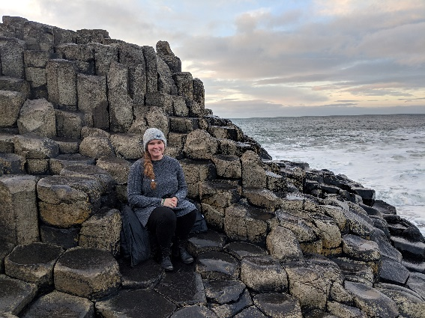
Lindsey at the Giant's Causeway, a UNESCO World Heritage Site in County Antrim, Northern Ireland
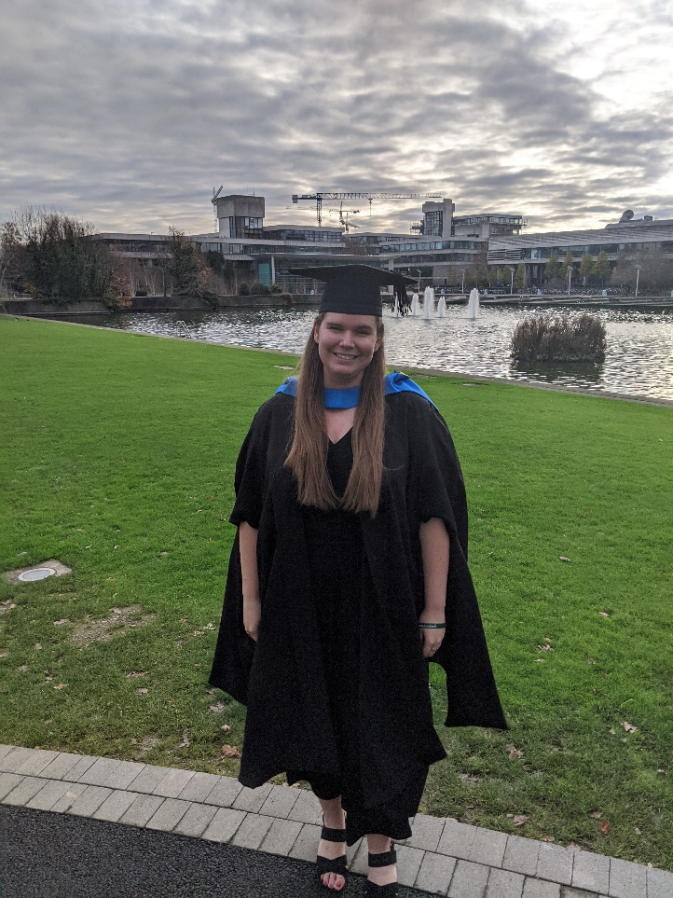
Lindsey celebrating graduation day from the MSc Equality Studies Programme at University College Dublin.
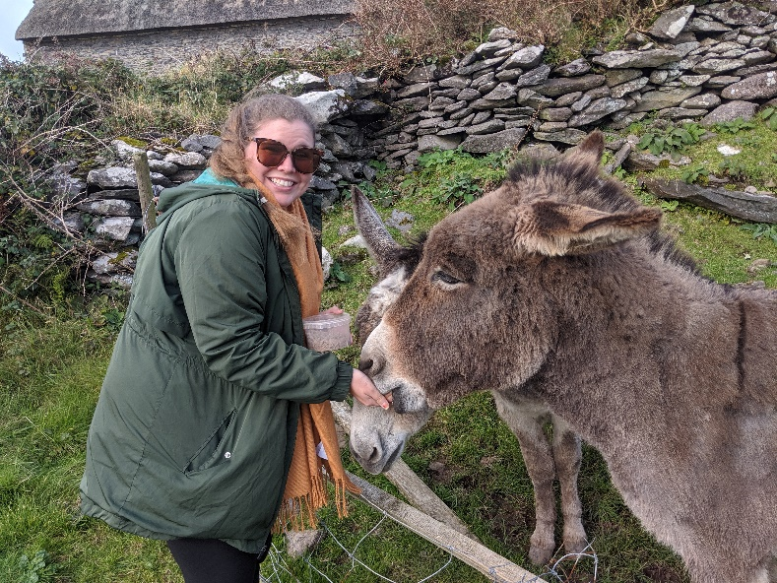
Feeding donkeys while traveling the Ring of Kerry in County Kerry, Ireland.
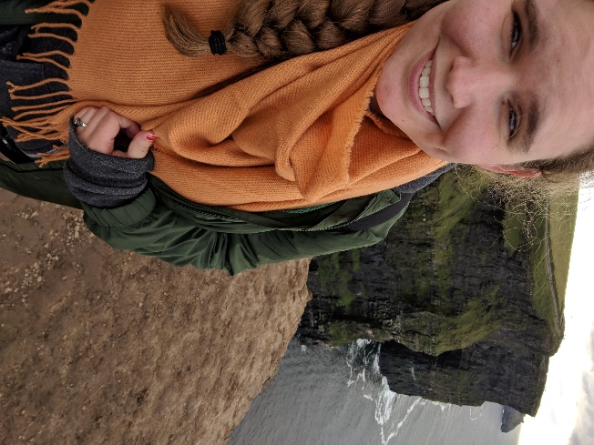
A visit to the Cliffs of Moher in County Clare.
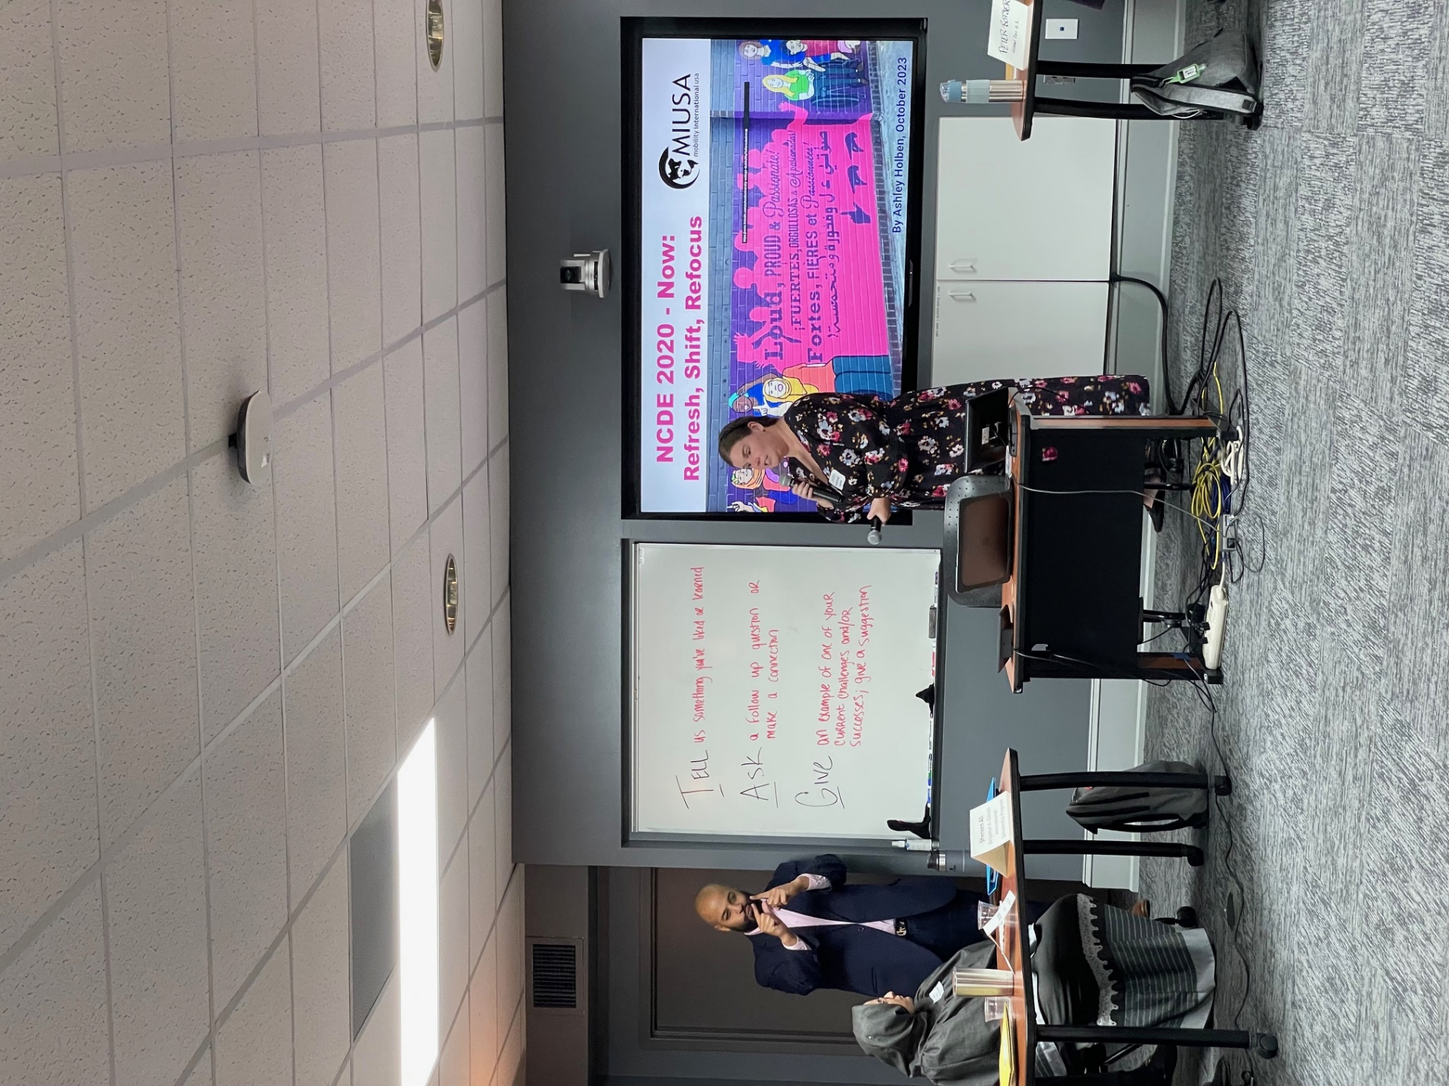
Presenting at a National Clearinghouse on Disability and Exchange event.

How a Sunflower Promotes Accessible Air Travel

Some people with disabilities may require reasonable accommodations when they travel. Disclosing a disability can be challenging, and this is often amplified when a person’s disability is not visible. The Hidden Disabilities Sunflower program was created as a tool used during air travel for individuals to discreetly and voluntarily communicate to airport staff that they have a disability. By wearing the sunflower lanyard, you let others know that you might need specific assistance, understanding or just more time.

According to the program, the sunflower symbol was chosen as it is visible from a distance and suggests positivity and strength while being a joyful image. Visit the website at www.hdsunflower.com to read stories of other travelers, find places that support people with non-visible disabilities, and locate participating partners where you can get a free sunflower lanyard to support you in your travels. More than 240 airports around the world have signed on to provide support for travelers with non-apparent disabilities through this program!

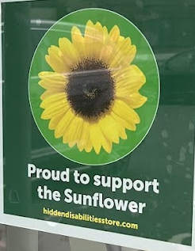
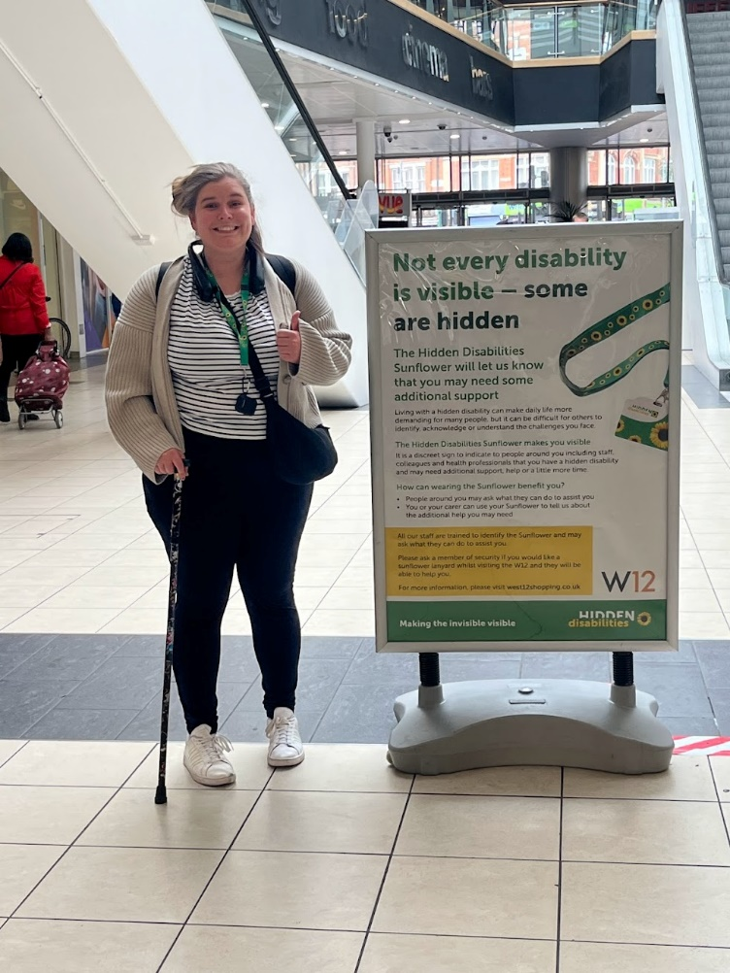
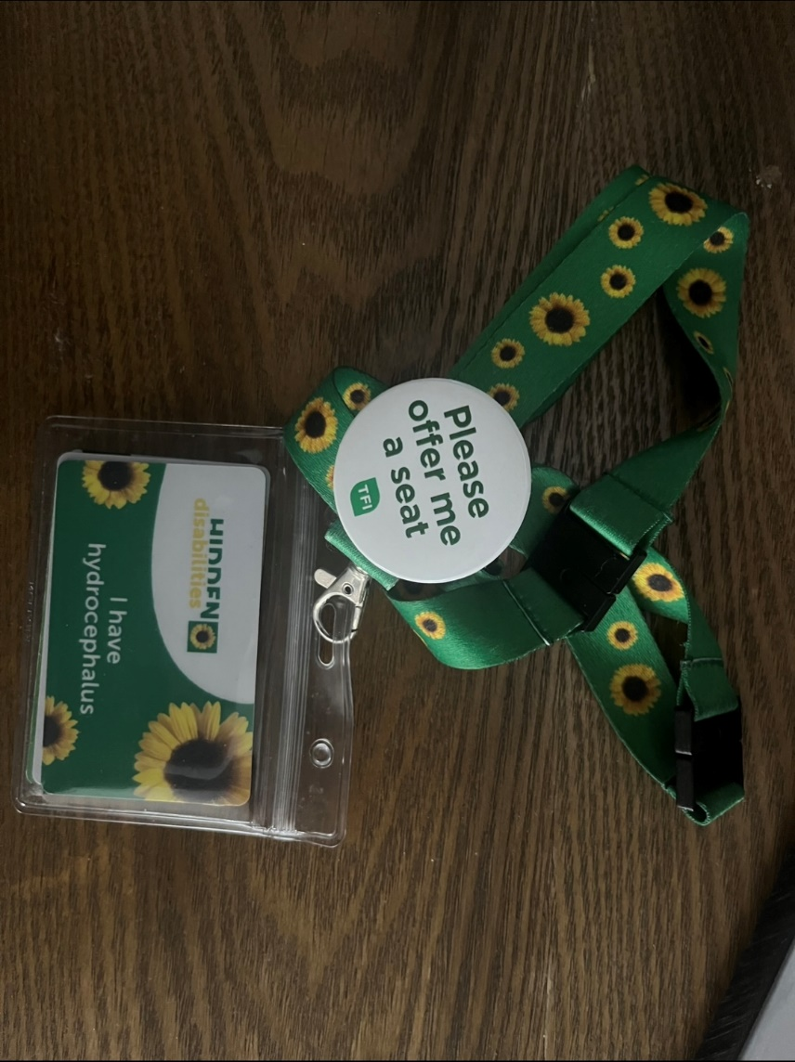

Bethany Kuwitzky: Navigating Disability Disclosure During Study Abroad in Iceland (When Not Disclosing Works)

Individuals must consider a variety of questions when evaluating whether to disclose a disability: When should they disclose? Who should they tell? Will they need to show documentation, such as a letter from a doctor? Will they be believed? Will they get the disability-related accommodations that they are requesting?

The complexity of the decision combined with past experience can lead some participants to choose not to disclose their disability to international exchange program staff or faculty. Nevertheless, these participants may have already planned on how they will manage disability related issues abroad.

During her undergraduate studies, Bethany Kuwitzky spent an academic year studying abroad in Reykjavík, Iceland through the Mid-American Universities International consortium. She took classes in geophysics and geology, which were related to her major. “My specific classes were incredibly unique and nothing like I was able to take at Texas Tech.”

She was also involved with a student organization called Fjallið, which translates to “the Mountain.” They would attend information sessions to learn about local companies and lectures on various topics. The group also organized a prom where Bethany was named Ungfru Skiptanemi (or Miss Exchange Student).

Disability Was Not at the Forefront
Bethany has rheumatoid arthritis and fibromyalgia, autoimmune conditions that result in limited energy and physical mobility. While her rheumatoid arthritis is mostly managed, the fibromyalgia can result in body aches, joint and eye pain, brain fog and intense fatigue. That means Bethany must be very intentional about punctuating active periods with rest. What most would consider to be a relatively light activity, such as a hike, could easily knock her off her feet for days.

While it may surprise some, disability was the last thing on Bethany's mind during the planning of her exchange experience. With so much to consider, she was mostly busy with logistical details like financing and packing. When she started to settle in on her program, it quickly became apparent that her disabilities would impact her day-to-day activities.

Instead of approaching program staff, Bethany decided to arrange her own support. Before studying abroad, she had found that disclosure did not always get her where she needed to be. Very often people would not understand the degree to which fibromyalgia caused pain, the reason for her brain fog or why she sometimes needed more sleep than others. “There were (and continue to be) many misconceptions around autoimmune disabilities, and I did not think people would classify it as a ‘real’ disease,” Bethany shared.

Non-Disclosure Does Not Mean No Disclosure
Although Bethany opted not to disclose to program staff, she shared about her disability with a network of trusted friends she made while in Iceland. Whenever she would have a flareup, her support system would make sure that groceries, homework assignments, and class notes made it to her apartment. While she had been able to bring a sufficient medication supply with her on a previous exchange program which only lasted a month, she would need refills during her year in Reykjavík. She connected herself with a local care provider recommended by her landlady, who also had an autoimmune disability. The provider looked over the list of medications that she had been taking in the US, wrote prescriptions for each, and recommended an alternative for a medicine that was not available in Iceland.

During one weekend when her symptoms had grown particularly unruly, Bethany decided to treat herself. She took a trip to a well-known tourist destination called the Blue Lagoon where she took a dip in a hot spring and got a massage. It was very expensive, but Bethany reflects that “the health services did help with some of my immediate fibro symptoms.”

Overall, these experiences helped Bethany to cultivate a greater sense of mental fortitude. Up to that point, she had found it to be very easy to settle into negative patterns of thinking, discounting what she could accomplish because of her chronic health conditions.

"I hiked mountains, walked on glaciers, flew a 4-person plane, climbed volcanoes, camped in the snow, zip lined, and so much more that I thought I couldn’t do."

A Formative Experience
Her fondest memory was taking a trip with her friends to a peninsula called Snaefellsnes to celebrate some birthdays. They rented a cabin at the foot of a mountain and spent the weekend going on hikes and visiting interesting destinations in a friend's car. The northern lights provided a vibrant backdrop throughout her entire year abroad.

Before her exchange experience, Bethany was focused on geophysics, but she very soon realized her keen interest in international education. Upon her return to Texas Tech, she became president of an outreach club to educate students about study abroad. And before she finished with her program she was hired on as a staff in the international programs office, where she continues to work today. ■

Bethany’s Photos
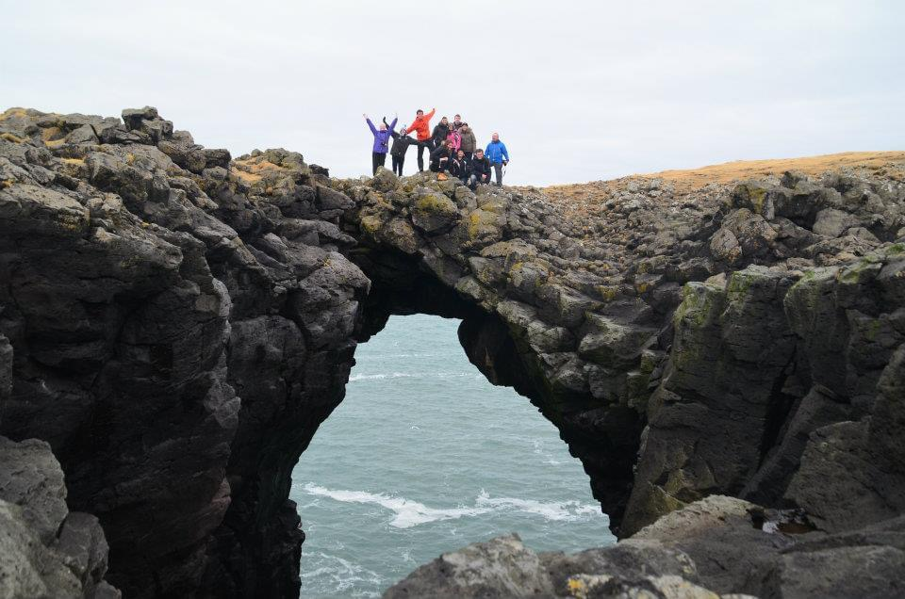
At Stone Bridge, a natural landmark located in the fishing village of Arnarstapi, Iceland.
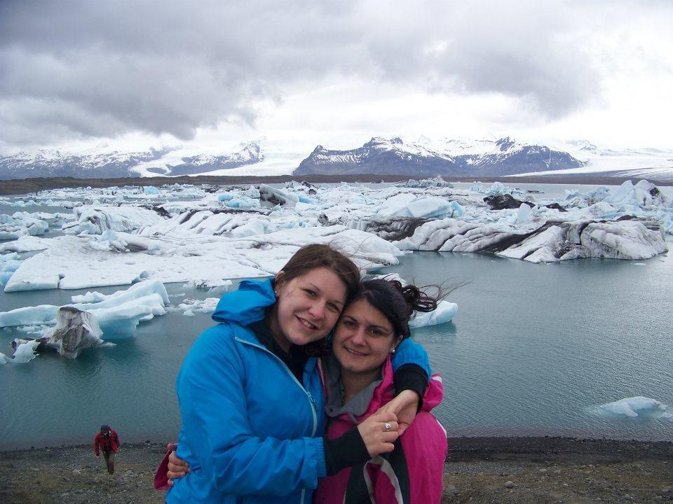
Bethany (left) with a friend at the Eyjafjallajökull glacier in Vestmannaeyjar, Iceland.
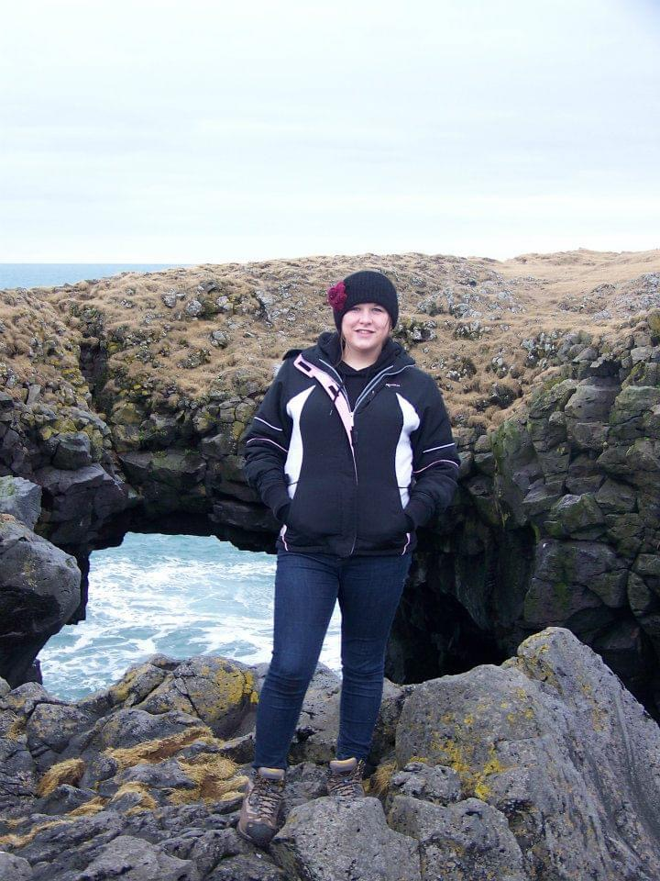
Bethany on one of many scenic hikes along Iceland’s Snaefellsnes peninsula.
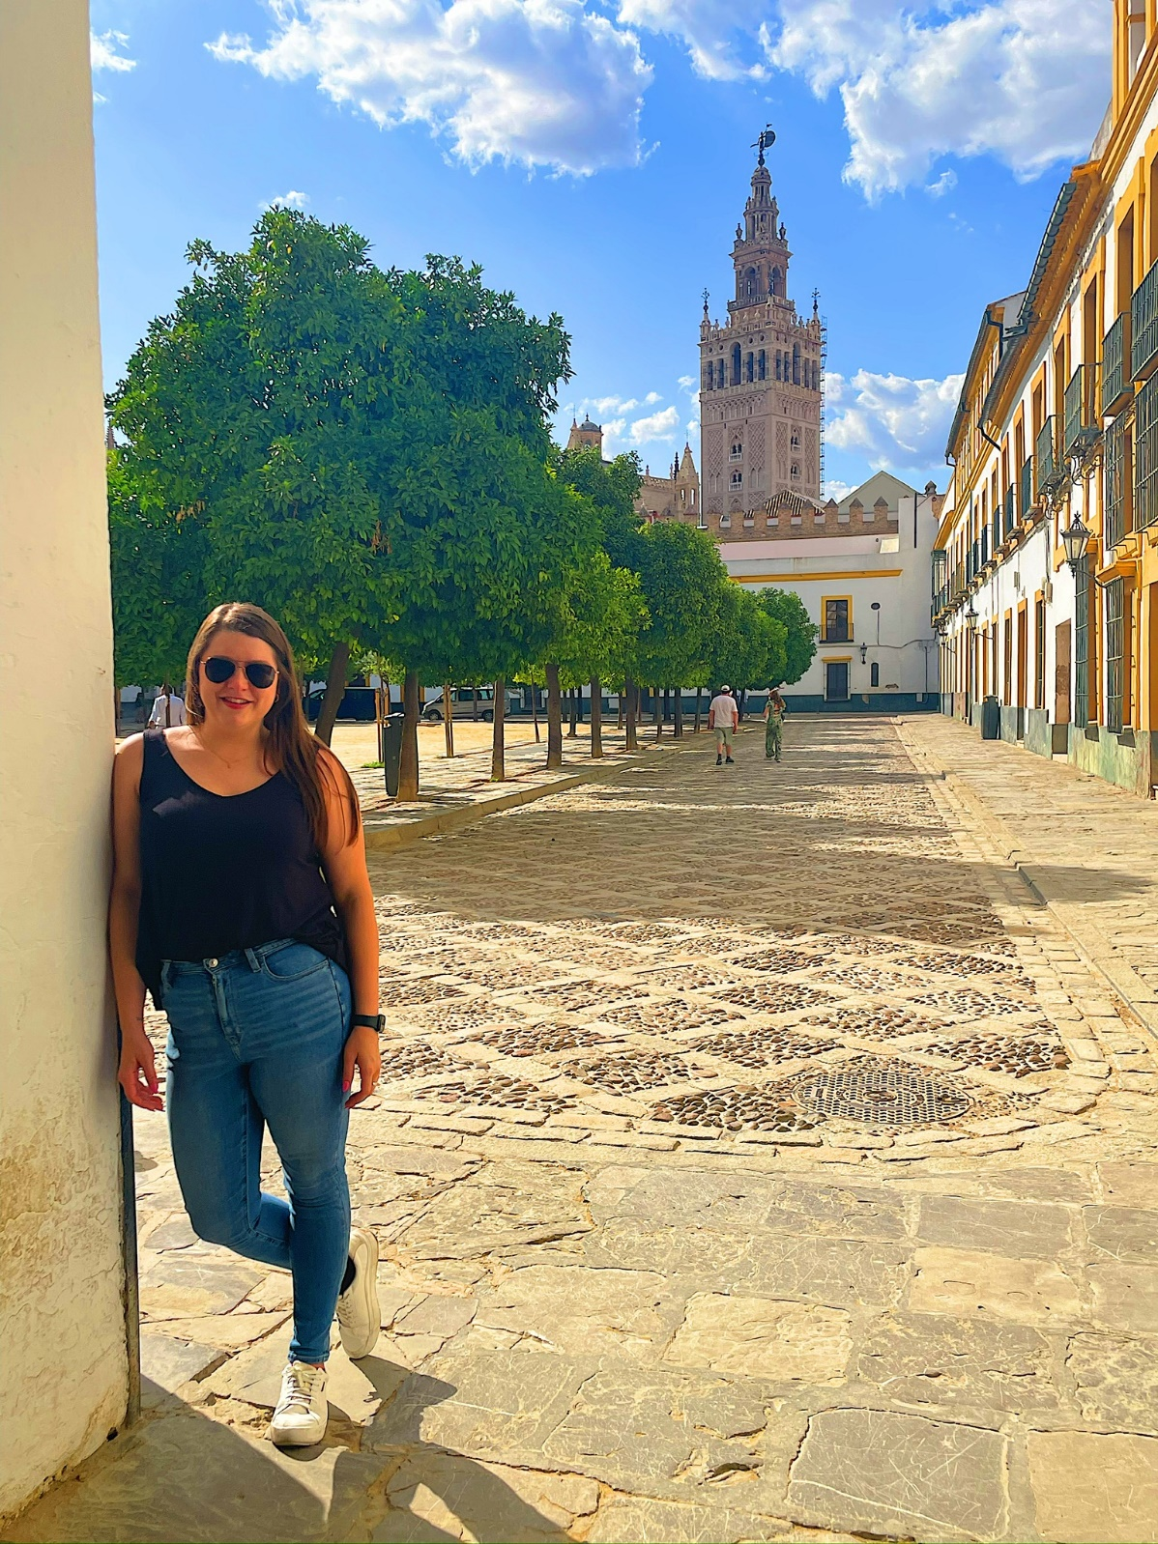
After studying abroad as a student, Bethany went on to work for Texas Tech as a study abroad advisor. In this role, Bethany traveled to various study abroad locations, such as Seville, Spain (pictured here).
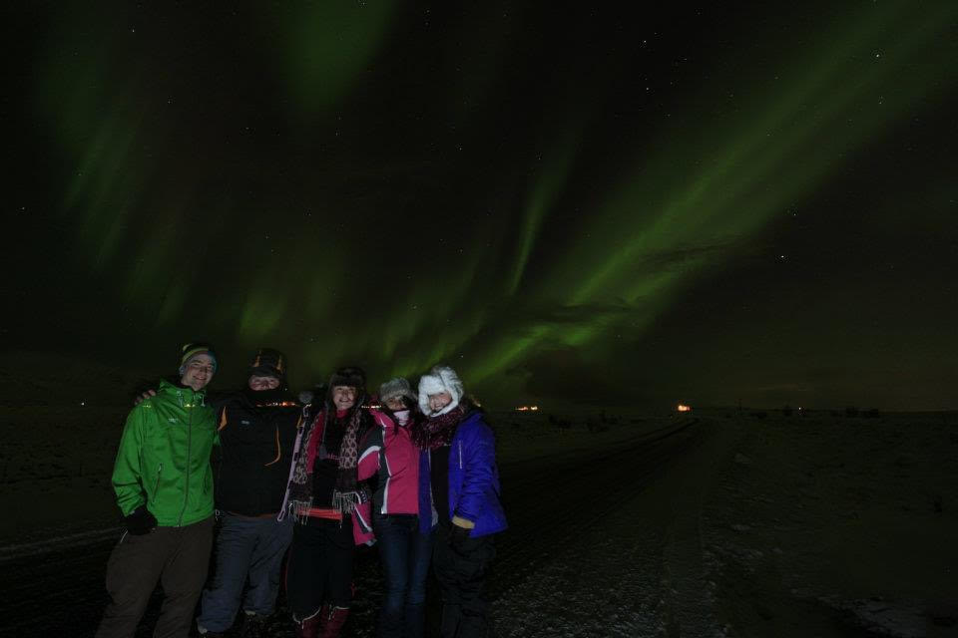
Iceland’s skies treat Bethany and friends to a dazzling display of the northern lights.
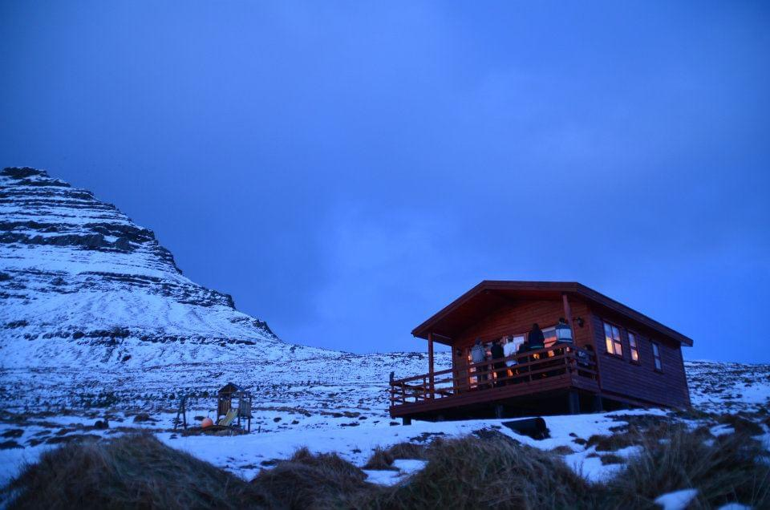
Bethany’s cozy cabin in Iceland’s Snaefellsnes.

Ways Exchange Professionals Can Encourage Participants to Disclose their Disabilities: From Bethany’s Perspective
Most students will not automatically feel comfortable disclosing aspects of their identity to staff and faculty. This includes disabilities, goals, and experiences. It is so important that international exchange professionals create spaces for students so that they feel safe to disclose anything about themselves that might impact their experience abroad. As someone who has experience both as an exchange participant with an autoimmune disability and now as an international education professional herself, here are Bethany’s suggestions for creating such spaces:

One-on-One Situations
- Ask students what they like to do to relax. After a student responds, I usually chime in with a blurb I have in my back pocket: “I have an autoimmune disease so for me, relaxing depends on the severity of my symptoms, but usually I like to bake.” I doubt the student cares what I do in my free time (we’re not there to talk about me), but in those first 5 words, I am sharing something about myself that makes me appear more vulnerable and open, and this can sometimes create a safe space for students.
- When talking about a program or university, highlight any resources they offer for disability accommodations or support. “For example, if I am looking at a partner provider program, I will go to their accommodation pages and discuss the support they can offer for specific things. I also usually mention here that I didn’t have this type of accommodation while studying abroad and follow up with how great it would have been to have university support during disease flareups. Again, this creates a space where they feel they can learn more about you, and hopefully that will help them feel safer opening up.”

In Larger Group Settings
(e.g. Pre-Departure Orientations)
- Give anonymous examples of how accommodation support has helped previous students with disabilities.
- Be clear that the purpose of disclosure is to aid the student, and not to deem them unfit or different. Make sure students know that disclosing a disability will not affect their ability to study abroad.
- Assure students that they may choose to use accommodations or not, but that it might be useful to learn what accommodations exist before making a decision. Many countries offer better support for students with disabilities than the United States, so U.S. students might find that they appreciate the accommodations they use abroad more than they do at home.
- Remind students that on-campus disability support follows them abroad.
- If students don’t feel comfortable disclosing to you directly, encourage them to reach out to their on-campus disability office.

Ally Baharoon: Living, Speaking, and Dreaming on the Mandela Washington Fellowship

A participant with a stutter from Tanzania experienced what it was like to be heard on the Mandela Washington Fellowship of the Young African Leaders Initiative. (Learn more about how to be a part of the next generation of African leaders! Visit https://www.mandelawashingtonfellowship.org/)

Ally Baharoon participated in the Mandela Washington Fellowship in 2023, hosted by the University of Delaware. Ally, who has a stutter, hoped that by learning more about organizational capacity-building and by forming contacts with like-minded professionals, the Young African Leaders Initiative would enhance his disability rights work in support of Tanzanian stutterers.

Finding a Vocation Through Disability
Ally first began to stutter when he was five years old, shortly after his father passed away. Soon after, the way people interacted with him changed. Listeners would no longer wait for him to finish his sentences. They would interrupt and even make fun of him. As a result, he preferred to keep to himself for much of his childhood. He focused on reading and writing as a way to express himself and took a great interest in English literature. He discovered that by making his speech more rhythmic and by carefully selecting his words, he could express himself better.

His attitude toward his disability changed upon graduating high school. He appreciated the ways that it enhanced his writing and interpersonal relationships. He started thinking about it as a speech pattern rather than an impediment and began to speak more openly about his stutter. He explained to people that it simply takes him longer to say things. Soon, he felt a huge burden lifted from his shoulders. His interactions with others felt more authentic.

Ally reflects that sometimes when someone has a different speech pattern, others assume that that person has nothing to say, or that if they did say something, it wouldn't be worthwhile.

He became steadfast in his belief that individuals with different speech patterns deserve to be heard. This led to him creating the CHAMMUTA Tanzania Special Speech Patterns Association, the objective of which is to create a society that welcomes children and adults who stutter. They carry out workshops with parents and teachers on speech differences and on ways to hold more inclusive and supportive spaces. His organization works with media outlets to challenge and avoid negative depictions of people with stutters. They also introduce young adults to stories of individuals with speech differences. “In CHAMMUTA, we thrive in embracing our differences because it is our stutter that makes us stand out”, reflects Ally. “It is by confronting these challenges that we highlight our primal responsibility to educate ourselves and build a world where what we say is more important than how we say it.”

The Mandela Washington Fellowship was an impactful experience for Ally. He and his group visited the Delaware state legislature, where they met with representatives and the governor. One particular highlight was when they were hosted by the Delaware Africa Coalition at an annual dinner. Ally reflected that "It was incredible seeing so many people of African descent in one place, and they made us feel so welcome with the home cultural foods." The coalition also encouraged them to keep in touch and explore opportunities for collaboration.

Observing a Different Way
While on the Fellowship, he noticed that people took the time to listen to what he had to say. They also recognized his abilities as an orator. They nominated him to represent his cohort as a speaker giving an Ignite Talk at the Mandela Washington Fellowship Summit, during which he shared about the events that had led him to found his organization.

A key part of his fellowship was his internship with the Bobby Dodd Institute, an Atlanta, Georgia-based nonprofit organization creating employment opportunities for people with disabilities. As part of his internship, Ally assisted in the creation of quality improvement plans for BDI consumers. He also got to be a part of the farewell party for the Getting Ready for Opportunities in Work (GROW) Program, which prepares high school students with disabilities for the world of work through site visits of local employers and activities to develop their job skills.

"Working at Bobby Dodd Institute allowed me ample time to appreciate their approach in including people with disabilities from the very beginning of their programming. It is really a people-centered way of promoting people with disabilities and making sure that they have all it takes to be engaged participants in our communities."

A Renewed Commitment
The Mandela Washington Fellowship has been a catalyst for Ally to reaffirm his focus and commitment to his work in his local community of Zanzibar. After returning home, he put on the first ever Zanzibar Book Fair in collaboration with the Zanzibar Literary Society, featuring a keynote speech from Nobel Laureate Prof. Abdulrazak Gurnah. The event lasted three days and offered visitors the opportunity to participate in panels, book launches, workshops, and poetry readings. Ally enthuses that "We were honored and grateful that some of our guests, coming from seven countries, flew in just to be part of this auspicious event." He also looks forward to hosting the first “Camp Dream. Speak. Live.” in Africa. This one-week camp was designed by the Arthur M. Blank Center for Stuttering Education and Research to enhance the leadership and communication skills of young children who stutter.

“I have been more enthusiastic about services I produce and have made connections that will build upon the community engagement work that I do. It has allowed me to see societal challenges in a different light, and coming up with implementable solutions is now the only way forward. I look forward to leveraging the incredible network that I have made to better serve our communities.” ■

About the Mandela-Washington Fellowship
The Mandela Washington Fellowship for Young African Leaders is the flagship program of the U.S. government’s Young African Leaders Initiative (YALI). Established in 2014, the Mandela Washington Fellowship has welcomed nearly 6,500 young leaders from every country in Sub-Saharan Africa to the United States for academic and leadership training. The Fellows, between the ages of 25 and 35, are accomplished innovators and leaders in their communities and countries. To learn more about this program, visit www.mandelawashingtonfellowship.org.

Ally’s Photos

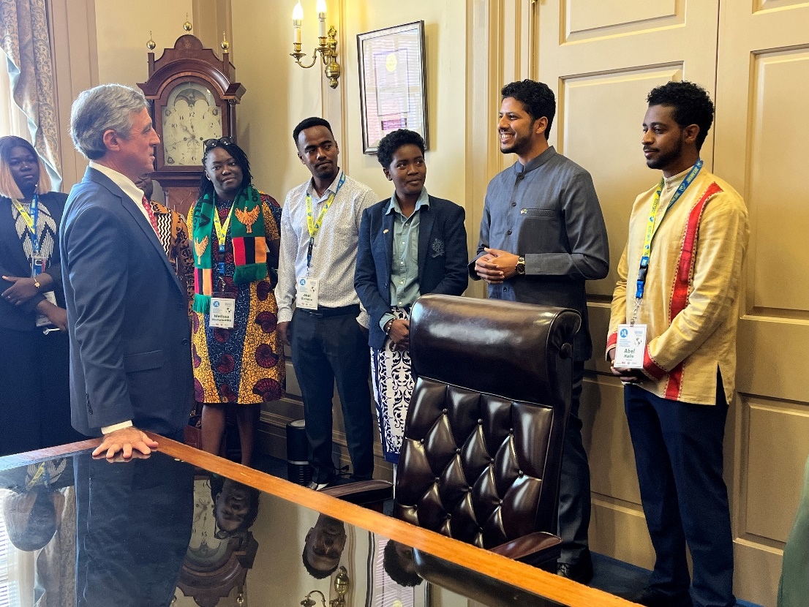
Along with other Mandela Washington Fellows, Ally (second from right) meets with Governor John Carney during a visit to the Delaware Legislative Hall.
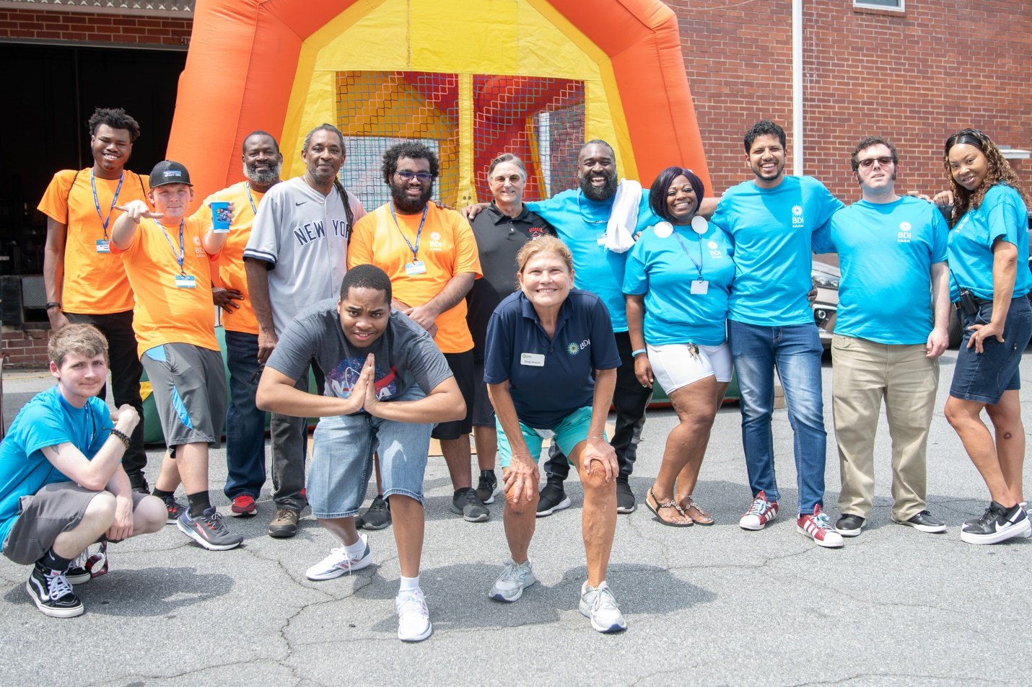
Ally (back row, third from right) joins the graduates of the Getting Ready for Opportunities in Work (GROW) program at the Bobby Dodd Institute main campus.

Kristen Popham: Taking Up Space in France

Kristen Popham spent the 2021-2022 academic year teaching English in France as a Fulbright English Teaching Assistant (ETA). This program places U.S. participants in classrooms abroad to provide assistance to the local English teachers. ETAs help teach English language while serving as cultural ambassadors for the United States. The age and academic level of the students varies by country, ranging from kindergarten to university level. Because of her chronic health disabilities, Kristen’s ETA experience would include more than grading assignments, leading classroom activities, and exploring her host community.

By negotiating accommodations for her chronic health disabilities with locals and healthcare providers, a Fulbright English Teaching Assistant learned to assert herself.

Proudly Fighting to be Believed
At the age of 12, Kristen was diagnosed with juvenile idiopathic arthritis, uveitis, and ankylosing spondylitis – autoimmune diseases that have never gone into remission and that have shaped much of her experience growing up. Identifying as chronically ill, she requires a variety of medications to be administered intravenously on a monthly basis. She doesn't hesitate to ask for assistance. She advocates to pre-board on flights so that she can have extra time to get settled in. Kristen considers herself to be a proud disabled woman. At the same time, she finds she sometimes must fight to be believed in certain spaces.

“I often ‘pass’ as able-bodied because of my illness’ invisibility; this gives me many privileges but also comes with challenges as a chronically ill woman fighting to be believed. I am someone who navigates my life with an uncertain relationship with my body and a close relationship with pain.”

It might not be a surprise, then, that Kristen was a bit anxious about disclosing her disabilities on her Fulbright application, fearing that it would be a liability or that it would not be believed. Kristen reflects that despite her anxiety about disclosing her disabilities, "my disability is so closely tied to my experiences, that it became a necessary part of my personal statements and certainly shined through in my application."

How to Cover a Chronic Health Condition in France
Despite her concerns, Fulbright staff responded with support. They worked to find what information they could for Kristen about disability in France. Also, from previous experiences, Kristen had learned how to obtain health insurance coverage under the French healthcare system.

Having a pre-existing condition that involves complex ongoing medical treatment can be one of the most challenging disability-related barriers to study abroad. Many travel health insurance providers do not offer coverage to pay for treatment. Although some countries have nationalized healthcare, it will only cover medical emergencies for foreigners. At the same time, individuals who face these barriers would potentially be overlooked at an in-person orientation or promotion event because their conditions are not visible.

Fortunately, France not only has nationalized healthcare, it is also reasonably manageable for foreigners to access services. According to French law, all residents, both French and otherwise, must have healthcare. Before someone can be covered in France, they must spend three months in the country to gain their residence. Until then, the individual must pay for their own healthcare costs. After that, the national plan covers 70% of an individual's fees, leaving them to pay for the rest. It also may reimburse them up to 70% for previous medical costs incurred during the three-month period before coverage kicks in.

Kristen initially paid for her healthcare expenses on credit cards while waiting for coverage. After three months, that coverage started, and the French government reimbursed her for its share of medical expenses, allowing her to pay down the cards. At the end of the program, Fulbright reimbursed Kristen for her copays.

Accessing Exclusive Spaces through Disability
“My autoimmune disease has enabled me to enter spaces that my able-bodied peers cannot. I converse in French with disabled women in infusion rooms across the country about the experience of being sick in their country. I learn the intricacies of a social welfare system from which the United States can learn. My biggest concern going abroad turned into my greatest asset.”

Kristen believes, based on her experience in France, that there are a lot of things that the United States could learn. The way that the French healthcare system supports the aspirations of international students and English teachers is unusual. On the other hand, she noted some areas where France could learn from the United States. While in the United States people are more in the habit of embracing their differences, in France sometimes that could be overshadowed by a notion of a “universal Frenchness.” Sometimes her French friends could not understand her disability identity, responding that she was just sick.

ETA is All About the Students
The biggest highlight of Kristen's experience was the students she taught. Her experience at Lycée Julie Victoire Daubié was so meaningful, and she integrated some of her favorite academic activities learned from the United States. In one case, the students debated the death penalty in a moot court. In another instance, they put Goldilocks on a mock trial. In another, they conducted a model UN simulation involving the United States and Russia. Students got so excited and riled up during the simulation that the teachers had to pause the class and remind them that it was only a game!

“These students taught me that I want to incorporate teaching and youth engagement into my future career in some way. I had the time of my life as their instructor.” ■

Kristen’s Photos

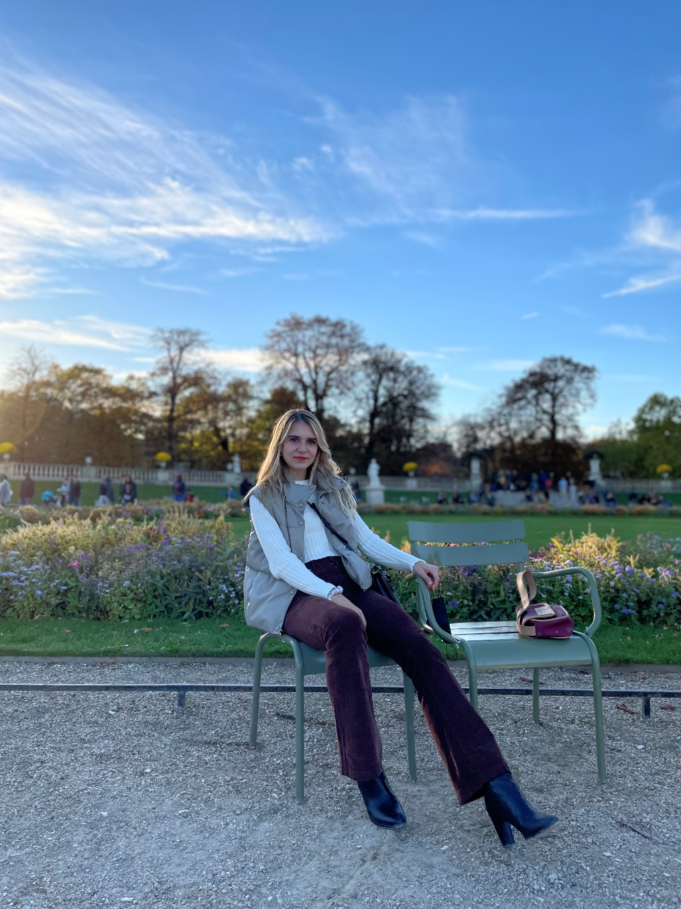
Kristen at the Jardin du Luxembourg
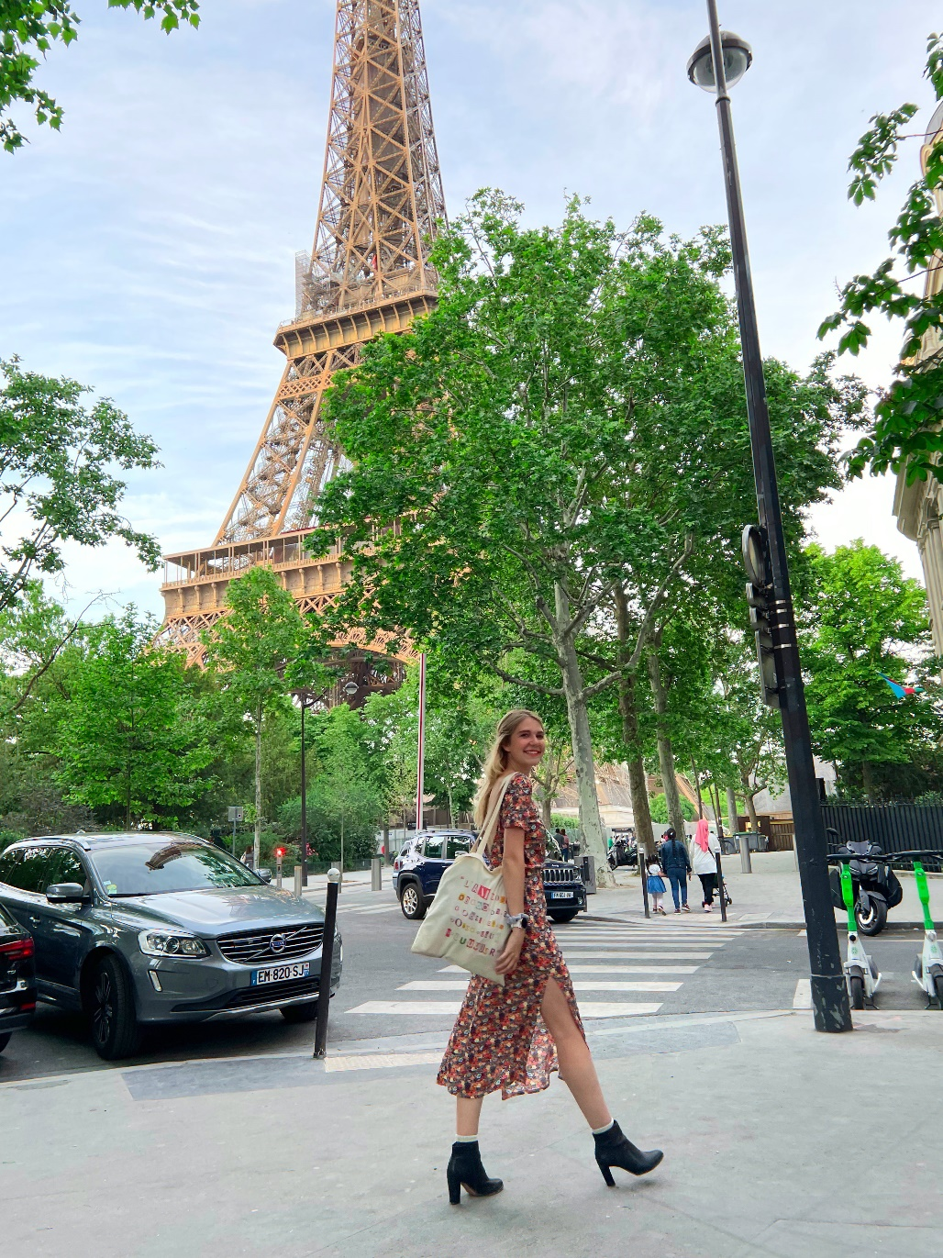
Kristen in Paris, France during her Fulbright year, 2022.
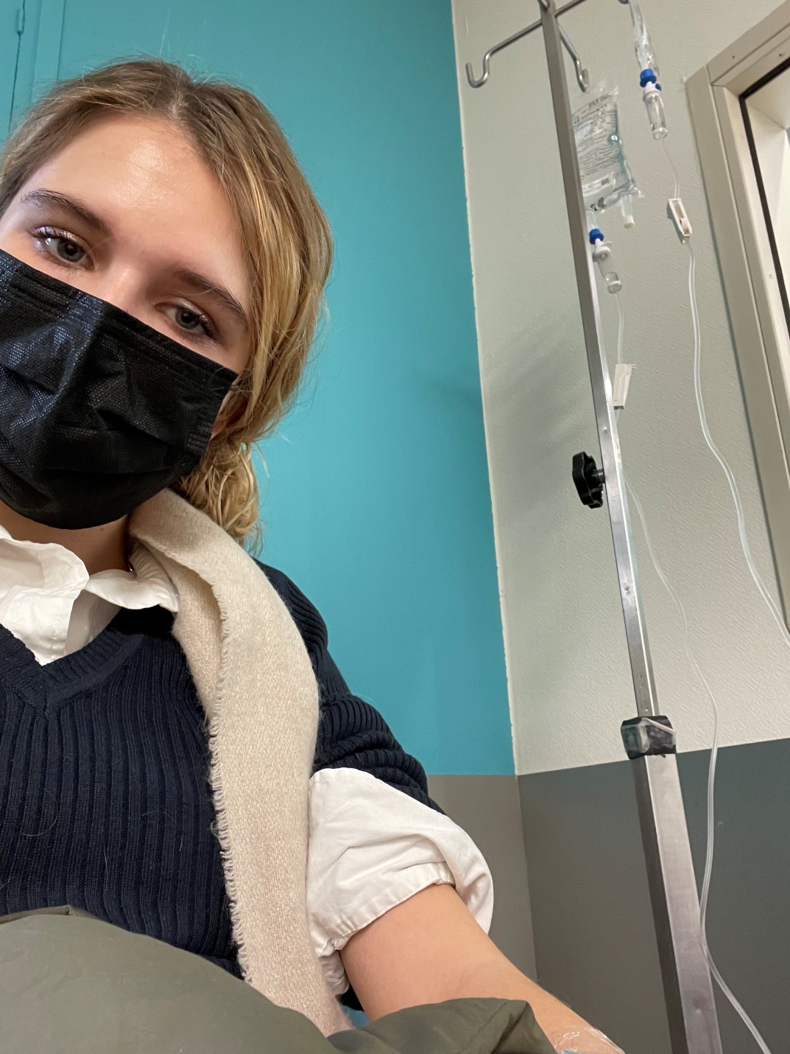
Kristen at a hospital in Paris, receiving an infusion for her rheumatoid arthritis.

Nicole Bettè: Design Thinking in Stockholm, Sweden

Nicole Bettè, a Latina bioengineering student from the University of Michigan at Ann Arbor with learning and chronic health disabilities, discovered the power of design when she spent a year studying nanotechnology, structural biology, and Swedish at the Royal Institute of Technology and Design Thinking at Konstfack University of Arts in Stockholm, Sweden.

Ever since she was young, Nicole had known that she wanted to study abroad. Her father had a job that caused him to travel frequently, and she was enamored by the stories that emerged from his travels. Both of her parents were also passionate about languages, and they transferred that passion to their daughter.

A Mix of Disabilities
Nicole has a mix of disabilities. Her autism spectrum disorder (ASD) and attention deficit hyperactive disorder (ADHD) impact her ability to focus in class and on exams. Her Sensory Processing Integration Disorder (SPD), which co-occurs with ASD, creates difficulties with sensory processing and makes certain sounds, tastes, or smells almost intolerable. She also has Ehlers-Danlos Syndrome and dysautonomia, which cause difficulty walking long distances and standing for long periods of time as well as the occasional dislocation of joints. Her endometriosis means periodic bouts of debilitating pain, causing her to miss class.

Unsurprisingly, disability issues were top on Nicole's mind when she set out to study abroad. She was concerned about how she would receive extra time on tests and excused absences, and how she would be able to maintain access to her medications. Though only her ADHD and endometriosis had been diagnosed at the time, she still struggled with her other conditions and was concerned about how they might impact her experience.

She was able to get extended time on exams without incident. Though she was nervous about disclosing her ADHD, doubting if it would be recognized abroad, teachers were supportive. For example, one of her professors gave her more time than she would have received in the United States.

Rationing ADHD Medication
The medications, on the other hand, were a different situation. Nicole was not able to buy her ADHD medications in Sweden, and she was not able to bring a sufficient supply with her. So, she had to economize. For most of the program she did without, limiting herself to times of particular need such as at exam time.

Another challenge came in the form of funding support. As a low-income student, she paid for her studies with university financial aid as well as scholarship support from a private foundation for STEM students and the U.S. Department of State’s Benjamin A. Gilman International Scholarship. One would think that with all that funding, she would not have had issues meeting basic needs; however, the scholarship from the private foundation would only send the remaining half of Nicole’s award at the end of the program, leaving Nicole with a large deficit that had to be made up with loans from family and credit card debt. By the time the remaining funding from that foundation was dispersed, it was not enough to cover the interest expense that she had incurred from the credit cards.

“The financial struggles represented the darkest, scariest, and most serious aspect of my study abroad experience.”

That is why Nicole would like to see more scholarships, like the Gilman, that provide access to all funding at the beginning of the program. Many low-income students cannot call on other resources if awards are paid in 50% increments.

At Home Away from Home
One aspect of her program that was definitely not a challenge was adapting to the different cultural backdrop. As someone who was raised in Puerto Rico by Cubans, she grew up feeling like her ways of doing things and thinking about the world were different from those of the Michiganders with whom she went to school. Given her different cultural background, moving from Michigan to Sweden was really like changing from one study abroad experience to another. In another way, going to Sweden was like returning home, in the sense that for the first time, she was recognized as an American, rather than that girl from Puerto Rico who happened to have a U.S. passport.

Her time abroad in Stockholm also helped her to clarify her career interest. A class she took on design thinking impacted her professional path by allowing her to realize her passion for design. Now she works in human factors engineering, a profession focused on ensuring that medical devices are developed with under-represented populations in mind.

“I use Design Thinking in my work as a Human Factors Engineer and inclusive designer in the medical device industry, and I’m a huge advocate for the principles I learned. It truly laid the foundation for the rest of my career, and I’ll always be incredibly grateful for that exposure and opportunity.” ■

Nicole’s Photo
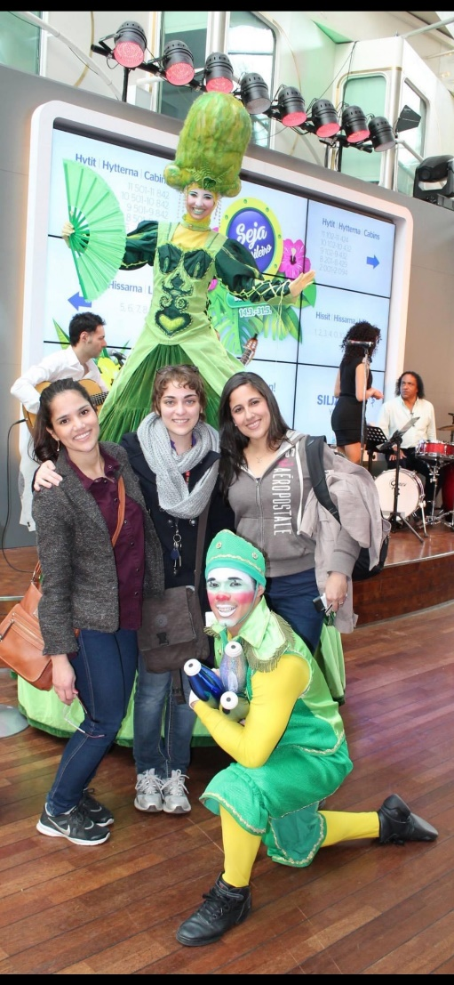
Nicole (center, wearing scarf) and friends enjoy entertainment from circus performers on a cruise ship traveling from Stockholm, Sweden to Tallinn, Estonia in the Baltic Sea.

About the Gilman Program
The U.S. Department of State’s Benjamin A. Gilman International Scholarship Program (Gilman Program) provides awards for U.S. undergraduate students who are receiving Federal Pell Grant funding at a two-year or four-year college or university to participate in study abroad or intern abroad programs worldwide. The Gilman Scholarship Program aims to support students who have been traditionally underrepresented in study abroad, including students with disabilities! Learn more at https://www.gilmanscholarship.org/

Ken Yamamoto: Understanding The World from Multiple Angles

When he decided to study abroad for four weeks in Kyoto, Japan at Doshisha University, Ken Uchiha, an autistic alumnus of the Benjamin A. Gilman Scholarship, found more than professional and academic experience. He gained a new perspective on Japan while getting to know his family better.

Honn and Tatemae
In many societies, there are social norms around how people communicate what they really want or think and what is considered appropriate or acceptable. This is particularly true in Japanese society where social harmony must be preserved. One's inner desires are known as honne, or what is under the surface, while what people express to the world is referred to as tatemae. It is assumed that in various social situations, people within a given society know how they are expected to behave.

For example, if you are visiting your Japanese friend whose mother asks you if you will stay for dinner, the correct response might be to say that you were just on your way out even if you might enjoy accepting the invitation. It is important to not disturb social harmony by expressing inner intentions that would be considered selfish by the majority. But what happens when someone doesn’t read the social signals necessary to adhere to these norms?

Ken set off on his study abroad trip familiar with how challenging this could be, having spent some of his childhood in Japan, struggling to navigate the complex social nuances. “I created many awkward situations and was either upset with myself or upset with others,” recalls Ken. At the same time, his Japanese heritage was a key motivator to learn more about the country.

Ken studied the types of social situations where these exchanges might arise. He went over each in his mind, and practiced his response.

But there were still hiccups. One day Ken went to the bus station to confirm that his Japanese bus pass was working. When he reached the front counter, the woman asked him how his day had been, and he proceeded to give her a full and unwanted account of all of the events leading up to that moment, when she was only making small talk. Ken reflects that “when you have an invisible disability, people will not understand why you don't get something.”

A Target on Your Back
While he was aware of services for students with disabilities, Ken preferred not to disclose his disability or request support from the University of Arizona or the host institution. Previously, he found that even when he did disclose his autism and asked for accommodations, support did not come. He also sensed that he was treated differently after people knew. In one instance, he requested that peers take more time to explain jokes, but then things continued as if he had not disclosed and made this direct request.
"I have heard how people talk about those with disabilities when they are not around, so disclosing almost puts a target on your back from my experience."

One avenue of support Ken did pursue was the U.S. Department of State’s Benjamin A. Gilman International Scholarship Program. The Gilman Program was a valuable resource for Ken while he participated in his exchange in Japan. Staff gave him information about the healthcare system as well as commonly used Japanese phrases. They also checked in regularly to ensure that he was having a positive experience.

A New Perspective
Ken found that studying abroad in Japan with his adult perspective was very different from growing up in the country as a child. He visited the same Kyoto shrines that he went to as a kid and was able to absorb a lot more information. According to Ken, “as an adult I am able to see all the details and truly appreciate everything in my culture.”

Spending time in a location where he had an aunt and uncle also meant that he had the chance to visit them. He helped with farm and house work and joined them in preparing and demonstrating his family’s traditional tea ceremony to others. They visited the Iga museum, named for the town where his relatives live.

Studying abroad and immersing himself in a culture that was still largely unfamiliar gave Ken a sense of empathy for those who do not understand his disability experience.

“Being a kid you just react to things; you don't see the big picture. You don't know as much. As an adult, I can now follow and understand the actions of others, knowing that conduct comes from a place of not knowing instead of ill will.”

His time in Japan gave Ken the push that he needed to learn how to understand peoples' inner intentions by looking at the world from their perspective. This new found empathy impacted his life for the better after returning to the States. It enabled him to find his first internship, and his first job, working in construction management. All this became possible from understanding the world from multiple angles. ■

Ken’s Tips for Preparing for Travel
- Look up the airports, figure out how they operate, the working hours, size of the airport, charging stations, religious rules, taxis, currency exchange, traffic laws, etc.
- Cross reference when your flight lands, traffic information, business hours of transportation method, city information related to traffic, and potential costs.
- Call ahead to the hotel and get information on contact numbers, crime rates, help desks, landmarks, best means of travel for arriving there, employee uniforms (especially if that hotel has a shuttle service), and what is nearby the hotel.
- Create a small list in the local language of phrases to say (that can also be read), address you're going to etc.
- Don't always assume your phone will have power.
- Figure out any laws that will apply to your initial travel. Nothing too deep just common headliners, no littering, no gum in public, dress code, etc. Lastly, create a plan of action and a backup in case the first doesn't work out. Send that plan to your local contact, and a family member.

Ken’s Photos

The dragon statue of the Kiyomizu-dera Temple in Kyoto, Japan.

Fushimi Inari Taisha, a shrine in Kyoto, Japan

Qazi Fazli Azeem: What Will People Say About You?
  - Originally written by Sophia McDonald Bennett, adapted for this publication by Justin Harford

Qazi Fazli Azeem applied to the U.S. Department of State-sponsored Fulbright Program because it allowed him to achieve two goals.

First, he needed a master’s degree. In Pakistan, he was on the faculty at the Indus Valley School of Art and Architecture, the country’s leading private non-profit arts and design university, but he wanted to advance to a permanent teaching position with a higher salary. Hence, the need for a master’s degree.
He could have pursued one in Pakistan, but he had a personal reason for coming to America. He is also the first self-advocate for neurodiverse individuals in Pakistan, including those with autism. Studying in the United States would give him an opportunity to meet and learn from the many American autistic self-advocates who had inspired him over the years through their interviews, books, and media appearances. It would expand his perspective for the work of educating his country about autism, in which he had been engaged since 2006.

A Life without a Diagnosis
Fazli found out about his own autism at the age of 25. Up to that point, he had experienced a great deal of success in his life. His family was able to send him to private school. He had started a career as a professional graphic designer and instructor. However, accompanying his success was an internal struggle. Environmental noises from babies crying to water dripping in a sink caused his ears to hurt. It was difficult to look people in the eye. Because of his social anxiety and discomfort with places with high sensory input, Fazli was most at ease in a library studying by himself.

Confirmation of his symptoms from Canadian doctors visiting Pakistan for a medical conference changed the direction of his life. After learning more about the autism spectrum, he identified solutions for his hypersensitivity issues. Noise canceling headphones helped him to block out extra sounds, and removing the hair from his ears minimized the intensity of other noises. He figured out that he could appear to look people in the eye by focusing on their nose, and he spent hours practicing on himself in the mirror to perfect this skill.

He made it a life goal to advocate for autism awareness and techniques for managing it in Pakistan. Creating awareness was an uphill battle. Pakistani doctors refused to formally diagnose him, because they did not have the training. Nearly 17 years ago, his home country of almost 200 million people had less than 400 trained psychiatrists. Fellow Pakistanis who also had been diagnosed as being on the spectrum by foreign doctors refused to support his efforts for fear of standing out. The local Urdu language of Pakistan has a saying, "loog kya kahein gaye", which roughly translates to "what will people say about you?" "It means...," explains Fazli, "that you should always fit in and do what everyone else does so that people have nothing special to say about you and that they do not talk about your individuality to preserve family and tribal "honor."

Becoming an Advocate
So he became the first and only openly autistic self-advocate in Pakistan. He sought out invitations to be interviewed on cable TV about the condition’s symptoms and solutions. He created a YouTube channel where he shared the interviews that he had done on TV. After seeing his interviews, parents and doctors began to reach out. Invitations to international conferences in India, Bangladesh, and Qatar followed. Soon the U.S. State Department took note.

The Fulbright Program arranged for Fazli to study at the Massachusetts College of Art and Design in Boston. While he was studying for his Master of Fine Arts in Design, he also took electives at the Massachusetts Institute of Technology’s Media Lab and received instruction and mentoring at the Harvard Innovation Labs.

Taking Risks and Making Discoveries
It was an eye-opening experience. “Design and its practice in the United States and European countries is radically different from how it is taught and practiced in Pakistan and developing countries. I learned user experience design, interaction design, and universal design, terms that I had not been exposed to during my education and career in Pakistan. My inclusive design focus and direction would not have been possible in my own country, and I was given an incredible amount of freedom to take risks and learn new things.”

Those risks paid off. One of his projects was developing a mobile learning app for school-aged children. His startup Curious Learning won a residency at the Harvard Innovation Lab, and his team showed off a prototype at Education Datapalooza, an event sponsored by the White House Office of Science and Technology Policy (OSTP) and the U.S. Department of Education.

Fazli also made great progress on his second goal while living in Massachusetts. “I was able to meet educators that I had looked up to: Lynda Weinman of Lynda.com and Sal Khan of Khan Academy. It was a conversation with Sal that led me to my design thesis research on inclusive interfaces for learners on the autism spectrum.” He attended a conference where he met with Eustacia Cutler, the mother of famed autistic self-advocate Temple Grandin. He spent time with folks from the Asperger Association of New England, including their director Dania Jekel, the great-granddaughter of Sigmund Freud. A high point of his trip, and of his life, was contributing to the writing of a book by autistic self-advocates from around the world entitled “Been There. Done That. Try This! An Aspie's Guide to Life on Earth”.

Participating in and accomplishing so much naturally involved a great deal of sensory input and unpredictability, but he developed strategies and used technology to adjust. One technique he employed was proprioception, wearing more clothes than needed to exert pressure all over his body, which lowered his anxiety levels when in public or interacting with strangers. This worked very well in Boston’s cold and wet climate, where he did not look out of place wearing multiple layers. He also made full use of technology such as Google Maps and social media to help him plan his activities and the best routes to get there.

What Will People Say?
After returning to Pakistan, Fazli’s career got a big boost. He became an Assistant Professor at the Karachi Institute of Technology and Entrepreneurship, and founded their school of design. Thanks to his leadership, the school granted its first Bachelor of Design degrees soon after.

Fazli also made a great deal of headway on his goal to educate Pakistani society about Neurodiversity. Centers on autism have been set up by the Pakistani government across the country. He later joined SZABIST University in Karachi where they designated him as the person in charge of disability accommodations, entrusting him with a great deal of responsibility to evaluate individual accommodations of students with disabilities and to offer recommendations for ways that the overall accessibility of the campus could be improved. His design support to the architect and disability communities in Pakistan played a role in standardizing wheelchair-accessible buildings in the country.
He has never been afraid to stand out, when fear of community stigma silenced others. “What will people say about you?” They will probably say quite a bit about Fazli. ■

Fazli’s Photos
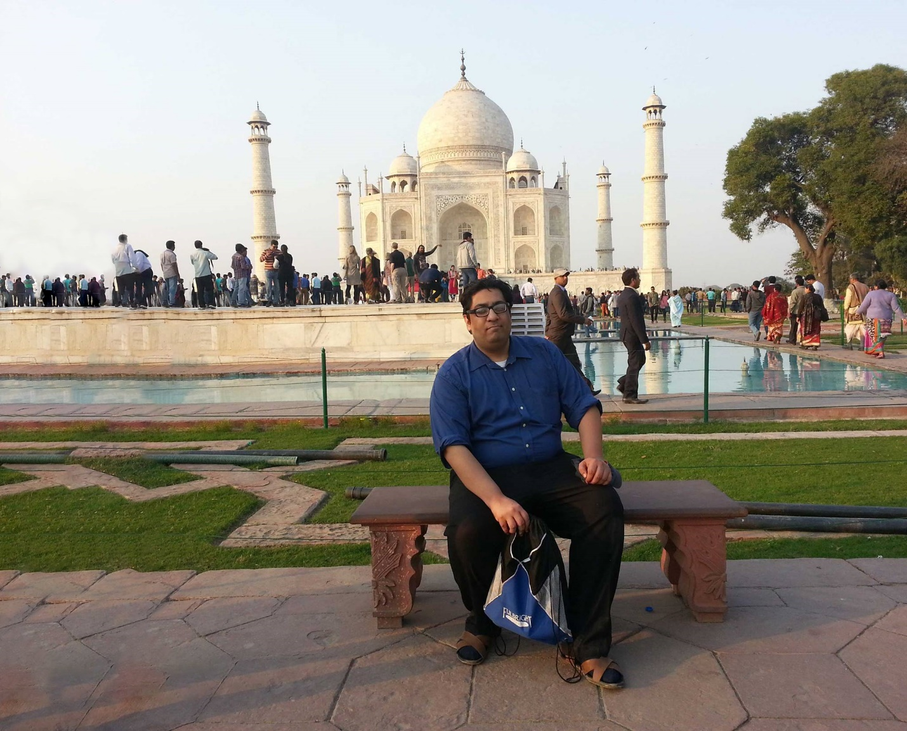
Fazli visits the Taj Mahal after speaking at the 2015 South Asian Autism conference in Delhi, India.
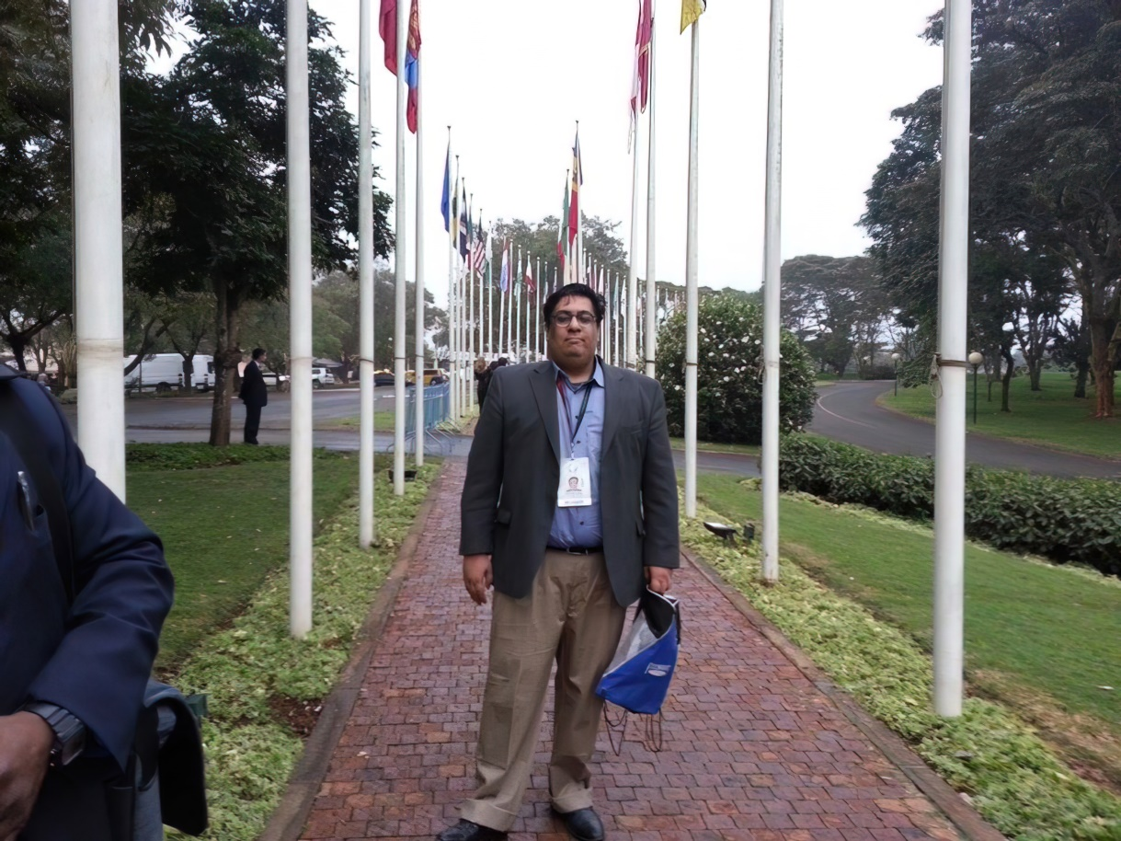
Fazli at the United Nations Office in Nairobi, Kenya, where he attended the 2015 U.S. Department of State’s Global Entrepreneurship Summit as Pakistan’s delegate.
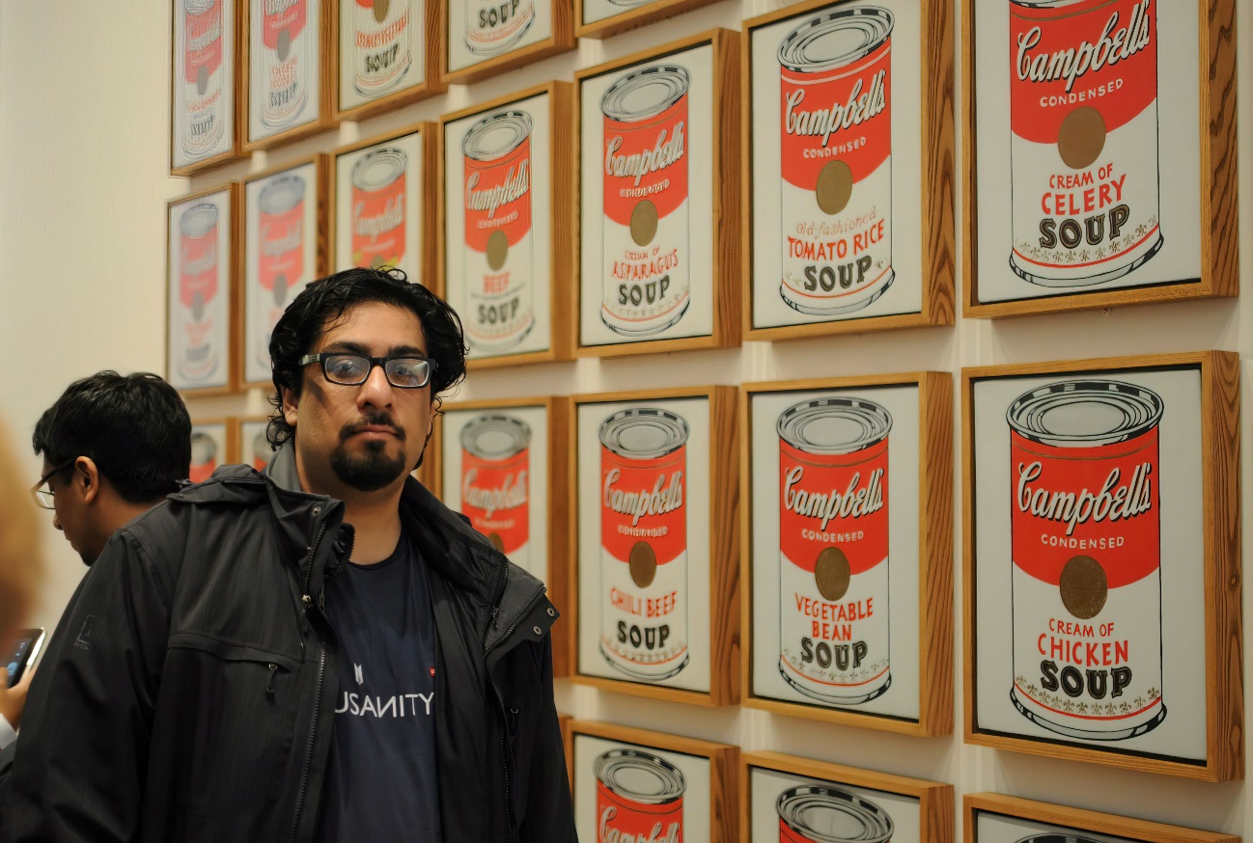
Fazli at the Museum of Modern Art in New York City, 2013.

