Studying Abroad for the Visually Impaired  in  Spain  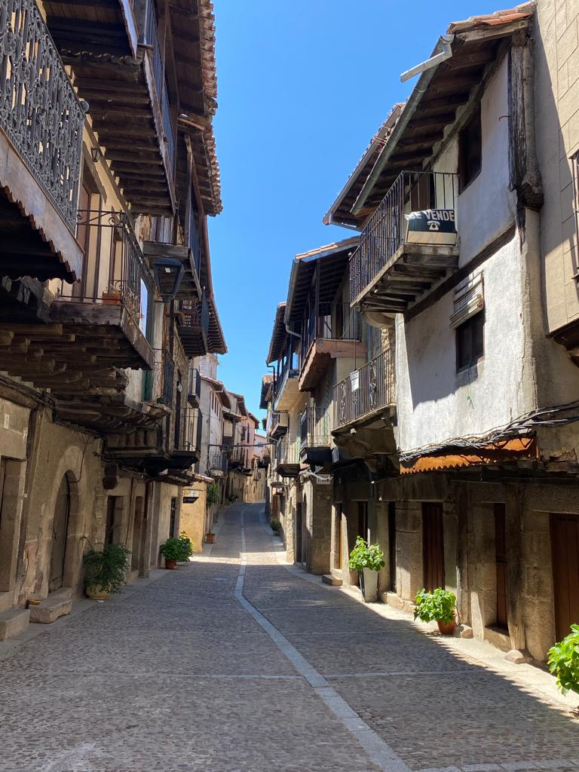 | Are you a student interested in studying aborad in Spain? Do you also happen to be visually impaired? This resource guide will discuss what to consider when studying abroad. What accessibility is already in place and how to go about taking advantage of study abroad opportunities as a student with a disability.

Developed by: Elizabeth Cappelli - Mobility International USA Extern 2024

Table of Contents
Why One Should Study Abroad 2
Disability Abroad 3
Cultural Perspectives, Access, and More 3
Going Abroad 3
Where 3
How Long 3
Connect with Disability/Accessibility Office 4
Accomidations 4
Navigation 4
Orientation and Mobility 5
Transportation 5
Mobility Aids 6
Technology 6
Braille Displays 6
Computer 7
Applications 7
Low Tech Devices 8
Common Concerns When Studying Abroad 10
Making Friends 10
Navigating a New City 10
Safety 11
Note to Friends and Family 11
Disability in Spain 12
What Legislation Exists 12
Rights for Guide Dog Users 12
Accessibility Practices for the Blind 12
Conclusion 13
Additional Resources 13

Author’s Note:
Thank you for taking the time to learn about study abroad. I am ecstatic that you are considering exploring this unique and exquisite learning and cultural opportunity. As you begin researching and making decisions about your time abroad it may become daunting and overwhelming at times. Don’t let that prevent you from taking advantage of this opportunity. This guide is a resource to better help you think about and plan your study abroad experience. Although this will assist you in learning how to prepare and what to consider when abroad remember that there are always challenges with every new adventure. Some days you will be in awe of everything you are doing and others you may encounter an obstacle. That is all part of studying abroad and each will teach you something new.

Reference to Visually Impaired:
Throughout this resource guide, I use the phrase “visually impaired” to identify individuals who are blind, legally blind, and have low vision. I use this wording because it is a phrase I often use. I feel that it conveys that individuals who are blind often have residual vision. Although the inclusion of impaired may appear to be negative I think it is important to recognize that it does not need to have a negative connotation. Rather, impairment could just be used to understand that one may struggle to use their vision, in the same another individual may be able to. This does not mean they are less capable but rather have found alternative ways to reach the same outcome.

Why One Should Study Abroad
There is something special about hearing the tap of a white cane on cobblestones, smelling fresh churros as you walk through a Plaza in Spain, and hearing a foreign language spoken all around you. This is a snapshot of walking through the small Spanish city of Salamanca as someone who is visually impaired. Studying abroad is not merely about exploring a new city, it is about expanding your comfort zone, and overcoming language barriers. Most importantly it improves your problem-solving skills, independence, and confidence. As someone who spent a month studying abroad in Spain during the summer of 2023, I want to take a few moments to express why it is critical to allow everyone to study abroad and what steps to consider when embarking on this journey.

Disability Abroad

Cultural Perspectives, Access, and More
There is a different perspective surrounding disability abroad, at least in Spain where I spent most of my time. I never felt that my blindness was a hindrance during my time abroad. If I ever needed assistance locating a restroom or store, I could ask a stranger and they would provide me with verbal directions or offer me human guide and show me where to go. It was wonderful to be in a culture that was aware of the needs of my disability without depriving me of my independence.

Going Abroad

Where
Where do you want to study? Are you interested in participating in a program within the United States or are you interested in going to another country? Would you prefer to live in a fast-paced city like Madrid or a small town like Toledo, Spain?

How long
The length of time one studies abroad is completely dependent on who they are. Some may wish to study abroad for a semester, others for a summer term. In addition, the desired length of time may shift as you explore study-abroad options. This length of time can be considered in a variety of ways. One may be based on finances, if one goes abroad during a typical semester any financial aid they receive is often applied to their typical tuition. It may also be easier to fufill required courses since more classes will be offered. Whereas if a student wishes to study abroad during the summer or winter term there may be less financial assistance provided by the institution and fewer class options. Another consideration is what events you may be missing while away. Will you miss family gatherings, holidays, and school events? In addition, if you decide to go abroad for a longer duration of time how will it be to be away from your family, friends, and support network? On the opposite side, one may gain more language skills and familiarity with an environment if they stay for a longer time.

Connect with Disability/Accessibility Office
After taking the time to determine what country you want to study in, it is important to begin considering what accessibility and accommodations you may need. Before choosing which program or school you are studying abroad through it is beneficial to inquire about what accommodations they may be able to offer and if they have supported students with disabilities previously.
It is also beneficial to connect with your home institution's disability office to discuss what accommodations may be important to have when studying abroad in a new enviorment. Along with connecting with the university or disability office of the school, you will be attending abroad. This will allow you to understand what support and experience they have with students with disabilities.

Accommodations
When considering accommodations it is important to recognize you will be in a new environment and developing a new support network. This will add additional tasks and possibly challenges. For accommodations consider what you tend to use at your home institution, what issues you may encounter in another country, and so forth. When I studied abroad the institution I was at had limited technology and therefore I had to work with the school administration to develop a system where I could access notes written on the board and worksheets handed out in class.

Navigation

Orientation and Mobility
For those who are visually impaired or blind, it can be challenging to navigate a new space. Particularly if you are living in an area that speaks a different language from your native one. I would recommend taking advantage of orientation and mobility services. This can be provided through a local blindness organization or possibly through your institution. Some students may even choose to travel abroad a week earlier to spend the time required to acquaint themselves with the new environment. This will allow you to have a better understanding of the layout and learn how traffic patterns work. There may also be specific adaptations that a local orientation and mobility instructor will be aware of that could be of use.
During my time abroad I did not receive orientation and mobility services. I was only abroad for a month and did not have enough leeway beforehand to plan for it. Some institutions such as the Universidad de Salamanca have a partnership with ONCE which is the local blindness agency to support students in study abroad efforts. However, it is important to consider that it could take time to find a provider. As well as determine what fees may be relevant and where to meet since you will be in a new place if you feel this service could benefit you, I would recommend looking into it.

Navigating Streets
While navigating the quiet streets of Salamanca, Spain I had little assistance from traffic lights or stop signs. Instead many of the streets, I covered were small two-way or one-way streets. To safely cross these streets I would use my residual vision and hearing to check for oncoming traffic. Then if applicable use parallel traffic to know when it is safe to cross. On rare occasions when I ventured further into the outskirts of Salamanca there were wider streets that had traffic lights, and the same was true when I visited larger cities like Madrid. In areas that had lighted traffic lights, they often had an audible pedestrian signal. This would make a noise to tell an individual when it was safe to cross. The incorporation of the system was equivalent to what we have for accessible crossings in the United States making it easy to transition the mobility skills I already had to this new environment.

Transportation
If you are traveling abroad, particularly in Europe you may notice there is a lot of public transportation. This is a wonderful component for people with disabilities. In Europe, some train stations have large print, tactile, braille, and high-contrast maps to provide a layout of the city. Almost all the transportation announces what stops are coming up, although you may need to become somewhat familiar with the local language since it will not always be provided in English.

Tactile Navigation
Many spaces in Europe have rubber paths on the ground with tactile lines. These paths are designed for people with visual impairments. One is able to use their white cane to trail these paths often leading to main points of interest. Whether that is a straight line to a rectangle to find a train door or another one to an escalator or staircase. Initially, these paths could be overwhelming if you are unfamiliar with the space you are navigating. Although they will provide an initial sense of direction.

Mobility Aids
Another component of navigation is the type of mobility aid chosen to use. This could include a white cane, a guide dog, a sighted guide, or no mobility aid. Throughout most of Europe a cane that is all white will identify an individual as visually impaired.
If you are considering studying abroad with a guide dog it is important to be aware of the legislation that is upheld in each country. For many countries, if you wish to visit with a guide dog it may take up to six months to plan out any veterinary visits or paperwork once needed prior to travel.
It is also important to carry an extra cane and cane tips. Whether you are a full-time or part-time cane user it is important to always pack at least one extra cane and tips. This is because you never know if your cane will break or get lost. It can also be useful to carry this extra cane in your backpack if you are traveling alone so you do not have to worry about a cane breaking and not being able to get to where you need to go.

Technology
As important as it is to be aware of technology for your classes at your home institution it is just as important to have reliable and comfortable technology to use abroad. There are a variety of options depending on your learning medium that could be helpful.

Braille displays
One option is a refreshable braille display. This is similar to a computer but in a smaller format often with a braille keyboard and one row of refreshable braille cells. This can be beneficial for braille readers because it allows you to access electronic documents, read books, write, and more on a small and accessible device.

Computer
It is also important to have access to a computer. If you are a screen reader or screen magnifier user the computer you are bringing must have this software on it. This way you will be able to access electronic information in an accessible way.

Applications
There are a ton of applications that you can download on your mobile device that can be helpful. Some of these are specifically for people with visual impairments while others are beneficial for visiting the country of Spain in general.
In addition, when considering applications, specifically travel applications it is necessary to think about access to international data. Nowadays it is possible to download an e-SIM or electronic SIM card which will download directly onto your phone and give you access to international cellular towers. These can often be bought for a certain number of days, weeks, or months. It is also possible to purchase a physical SIM card which would also allow you to connect to local cellular towers. Lastly, many cellular carriers offer international plans where you can purchase a certain daily or monthly price to have access to international data. It is important to consider how long you will be away and how much funds you are willing to spend on this service.
Applications to Consider:
Renfe: This is the Spanish railroad company app. It can be used to plan trips, look at schedules, and buy tickets.
Omio: This is app works throughout Europe and will provide you with information about all forms of public transportation including trains and bus. It also allows you to plan trips and purchase tickets.
Soundscape: This is a mobility app that provides its users with an audible 3D version of a space. You are also able to preview spaces before visiting them. It also utilizes haptic feedback to provide dual input about locations.
OKO: This is an app that works without Wi-Fi or cellular data. It allows the user to use their smartphone camera to look at a pedestrian signal. The app will haptically inform you when it is dangerous to cross an intersection and when it is safe.
Clew: This is an indoor navigation app that allows you to take a video of a route. You can then reverse the route and follow it back with verbal and haptic cues or save the route to use again in the future. It can be useful when navigating a new space or a space you will be visiting frequently.
Transit: This is an app that lets you see what public transportation lines are near you and provides real-time information about their arrival. It also gives you directions to the stops, and you can follow along on the map and list of stations when riding the transportation.
Aira Explorer: This is an app that allows you to connect with a trained visual interpreter. These agents have been trained to provide descriptive and accurate information. Although it is possible to obtain five free minutes every 48 hours you can pay for a monthly subscription.
Be My Eyes: This is an app that was developed in Denmark and has a variety of functions. One is that you can call a sighted volunteer who can provide you with verbal information to assist you with a task. There is also a Be My AI feature which is newer. This feature allows you to take a picture of anything and it will develop a description of it. This can be used to read documents, know what items are in your fridge, read small labels, and much more. You are also able to ask follow-up questions to the AI robot to gain a more detailed understanding of the image. If this does not provide enough information you can call a volunteer to assist you further There is also a feature that allows you to call sponsored businesses some are blindness related such as the Carroll Center, and others are non-blindness-related businesses.
Seeing AI: This is an app developed by Microsoft. This app has a variety of features. Including a short text reader. If you hold your phone over a short piece of text such as a label or sign at a museum, it will read the information aloud. You are also able to change the language. There is a document reader that allows you to take a picture of a document, it will then put it into text where you can change the font size and have it read aloud. There is a color, money identifier, barcode reader, and light detector. It also lets you take a picture of a scene, or a person and it will describe them to you.

Low-tech devices

Monocular
A monocular is a small telescope that is only a few inches long and can fit into a pocket. This is a beneficial tool for anyone with residual vision to view signage, written information, bus information, menus above counters, and more. A monocular is also beneficial because it provides you with this access without the fear of the device dyeing.

20/20 pens
These are pens that are in essence thick black markers similar to permanent markers. They can be used to see written information more clearly on paper.

Magnifier
A magnifier may be useful for an individual to view in-class documents and make information more accessible without the worry of an electronic device that may lose power.

Braille Slate and Stylus
Another wonderful low-tech way to access Braille on the go is with a slate and stylus. This would allow you to easily take notes during class or when exploring. You could bring along a small notebook that has medium thickness paper which would make it possible to write in Braille. This would also be a way to take notes in Braille without the concerns of an electronic device dyeing or not working properly.

Common Concerns When Studying Abroad
Studying abroad is nerve-wracking for any individual. Students will be developing new relationships, learning a new city, and possibly language. It is important to recognize that it takes a lot of courage for anyone to make the decision and action to go abroad.

Making Friends
A concern for many students going abroad is making new friends. It is important to remember that many of the students abroad are experiencing this together. It is beneficial to become involved in your international school’s activities or meet people at your residence. Along with connecting with locals at community events. It may take time, but as you become more comfortable you will continue to grow your relationships. It is also a great idea to attend meetings with your institution or study abroad provider to connect with others beforehand.
For myself, the international school I attended had a weekly calendar of events. These included local cooking classes, bachata classes, escape rooms, and rock climbing. They were ways to connect with other students at the school and learn more about the area we were living in. They are some of the fondest memories I have of my time abroad because I was engaging directly with the community.

Navigating a New City
Navigating a new city is often stressful and may be overwhelming. Prior to traveling to a new place, explore with an online program such as Google Maps or Soundscape. Both allow you to explore a place on street view visually or auditorially allowing you to become more familiar with the environment you will be traveling in. Furthermore, if you can work with your study abroad office to connect with students who have traveled there previously, these students may be able to provide insight into how the city is laid out.

Safety
While abroad I never felt unsafe, particularly as a woman who is visually impaired. As I became more comfortable with the city, I would explore new streets and stores. To be in an environment that was foreign and felt safer than anywhere I had been was magical. I had never experienced such freedom. It touches on the culture in Spain which focuses on the enjoyment of life. Throughout the day people will be working, but they will enjoy coffee at a cafe with their friends or tapas and a glass of wine in the evening. It focuses on creating connections with the people around you and embracing the experiences you have.
Although an environment may feel safer to explore and be in, that does not mean you should let your guard down. It is common practice to be pickpocketed while abroad in Europe. To avoid this it is important to be aware of where your phone, wallet, and any important documents are. It is best not to leave your phone on a table when at a restaurant where it may be grabbed. As well as not having your wallet in your back pocket where someone may be more likely to grab it. I would recommend having a passport holder that can be placed under your clothes or in a secure pocket in a purse or backpack. Also, think about important safety when determining what technology you pack. If you are hesitant to bring an expensive piece of equipment like a Braille display consider bringing a slate and stylus which is not enticing and may even be easier to carry to take notes.

Note to Friends and Family
As a family member or friend, it can be scary to allow someone you care about to go off on their own. Particularly, if they are an individual with a disability. As difficult as it can be it is imperative to provide this individual with self-determination and allow them to have the option to make this decision. This won’t be an easy experience and they will make mistakes without their usual support network. Although, this will provide the individual with a multitude of experiences and opportunities to learn from.

Disability in Spain

What legislation exists

European Blind Union
The European Blind Union has a page of information that answers commonly asked questions regarding blindness and access in Spain. This includes information on legislation regarding one’s rights and accessibility in Spain. It also has information about policies specific to those who are blind. Information about what mobility tools are utilized, access to transportation, and independence in one’s daily life. It includes statistics and specific legislation information.

Convention on Human Rights Persons with Disabilities
This legislation was adopted by Spain in 2007. It describes the equal rights and access those with disabilities have. People with disabilities have access to transportation, opportunities, education, and more. This legislation also discusses access to health and legislation specific to women, children, and adults with disabilities.
Link: https://www.ohchr.org/en/instruments-mechanisms/instruments/convention-rights-persons-disabilities

Rights for guide dog users
Guide dogs have similar rights to service animals under the Americans with Disabilities Act. In Spain, guide dogs specifically are allowed in public spaces. This is defined as public establishments and public transportation. However, Spain is divided into different autonomous communities which may have more specific rules regarding service dog and guide dog access. For example, some regions may only allow guide dogs while others may have expanded this to service animals that support individuals with other disabilities. To learn more about this the Foundacion ONCE Perro Guias has specific information for each region.
Link: https://perrosguia.once.es/legislacion/leyes-autonomicas

Accessibility Practices for the Blind:
Navigating any new place can be a challenge especially if you are visually impaired and are unable to see the environment around you. In Spain, there are a variety of features that support visually impaired travelers including tactile maps. For example, some cities may have braille maps provided by ONCE which is the national organization for people with blindness in Spain. Other tourist offices may have wooden table tactile maps of their city such as braille maps

Conclusion
Overall, as you embark on this study abroad journey embrace the challenges and be ready to grow. It will be an amazing experience where you will create many memories and friendships. It will allow you to go beyond your comfort zone and learn more about yourself. Most of all enjoy the unknown because it may turn out better than you ever imagined.

Additional Resources

ONCE
National organization for the blind in Spain. They provide services including orientation and mobility, vision adaptation services, and more to those who are visually impaired. They also work with many Spanish cities to make their spaces more accessible. Along with being the sole provider of guide dogs in Spain.
Link: https://www.once.es/otras-webs/english/what-is-once

Accessible Barcelona
This website will give you all of the information you need regarding accessibility in Barcelona. It has the option of sorting accessibility by disability type or activity. It is possible to learn about accessible features at tourist attractions such as Parque Guell.
Link: https://www.barcelona-access.com/?idioma=3

Accessible Salamanca
This is the official tourism website for Salamanca, Spain. It includes an entire page that discusses what accessibility Salamanca has for visitors including braille maps that can be borrowed.
Link: https://salamanca.es/es/accesibilidad

